Contents

Code 3

RAM (Synchronous) 3

Select and Encode Logic 4

CON_FF Logic 9

R0 11

Datapath 12

Block Schematics 35

Datapath 35

Testbench Files 36

Load 36

Load Immediate 42

Load with Register Offset 49

Load Immediate with Register Offset 57

Store 64

Store with Register Offset 72

ADD/AND/OR Immediate 82

BRZR/BRNZ/BRPL/BRMI 89

Jump 98

Jump and Link 105

MFHI/LO 112

Out 119

In 126

Output Waveforms 134

Load R1, $55 134

Load R0, $35(R1) 134

Loadi R1, $55 135

Loadi R0, $35(R1) 135

Store $90, R1 135

Store $8F, R1 135

Store $90, (R1)R1 136

Addi R2, R1, -5 136

Andi R2, R1, $26 137

Ori R2, R1, $26 137

Brzr R2, 35 (branch correctly taken) 137

Brzr R2, 35 (branch not taken) 138

Brnz R2, 35 (branch correctly taken) 138

Brnz R2, 35 (branch not taken) 139

Brpl R2, 35 (branch correctly taken) 139

Brpl R2, 35 (branch not taken) 140

Brmi R2, 35 (branch correctly taken) 140

Brmi R2, 35 (branch not taken) 141

Jr R1 141

Jal R1 142

Mfhi R2 142

Mflo R2 142

Out R2 143

In R1 143

Memory Contents 144

# Code

## RAM (Synchronous)

library ieee;

use ieee.std_logic_1164.all;

use ieee.numeric_std.all;

entity ram32 is

port (

clk : in std_logic;

reset_n : in std_logic;

w_en : in std_logic;

r_en : in std_logic;

dataIn : in std_logic_vector(31 downto 0);

addr : in std_logic_vector(31 downto 0);

dataOut : out std_logic_vector(31 downto 0)

);

end entity;

architecture behaviour of ram32 is

type ram_array is array(0 to 511) of std_logic_vector(31 downto 0);

signal ram : ram_array;

begin

process(clk, reset_n)

begin

if (reset_n = '0') then

ram <= (others => x"00000000"); -- set all ram values to 0;

-- Here is where ram is initialized for each instruction

elsif (rising_edge(clk)) then

if (w_en = '1') then

ram(to_integer(unsigned(addr(8 downto 0)))) <= dataIn;

elsif (r_en = '1') then

dataOut <= ram(to_integer(unsigned(addr(8 downto 0))));

end if;

end if;

end process;

end architecture;

## Select and Encode Logic

library ieee;

use ieee.std_logic_1164.all;

use ieee.numeric_std.all;

entity select_and_encode is

port (

IRout : in std_logic_vector(31 downto 0);

Gra : in std_logic;

Grb : in std_logic;

Grc : in std_logic;

Rin : in std_logic;

Rout : in std_logic;

BAout : in std_logic;

R0out : out std_logic;

R1out : out std_logic;

R2out : out std_logic;

R3out : out std_logic;

R4out : out std_logic;

R5out : out std_logic;

R6out : out std_logic;

R7out : out std_logic;

R8out : out std_logic;

R9out : out std_logic;

R10out : out std_logic;

R11out : out std_logic;

R12out : out std_logic;

R13out : out std_logic;

R14out : out std_logic;

R15out : out std_logic;

R0in : out std_logic;

R1in : out std_logic;

R2in : out std_logic;

R3in : out std_logic;

R4in : out std_logic;

R5in : out std_logic;

R6in : out std_logic;

R7in : out std_logic;

R8in : out std_logic;

R9in : out std_logic;

R10in : out std_logic;

R11in : out std_logic;

R12in : out std_logic;

R13in : out std_logic;

R14in : out std_logic;

R15in : out std_logic;

c_sign_extended : out std_logic_vector(31 downto 0)

);

end entity;

architecture behaviour of select_and_encode is

signal opcode : std_logic_vector(4 downto 0);

signal ra, rb, rc : std_logic_vector(3 downto 0);

signal s : std_logic;

signal decoderIn : std_logic_vector(3 downto 0);

signal decoderOut : std_logic_vector(15 downto 0);

begin

opcode <= IRout(31 downto 27);

ra <= IRout(26 downto 23) when Gra = '1' else (others => '0');

rb <= IRout(22 downto 19) when Grb = '1' else (others => '0');

rc <= IRout(18 downto 15) when Grc = '1' else (others => '0');

decoderIn <= ra OR rb OR rc;

s <= Rout OR BAout;

with decoderIn select

decoderOut <= x"0001" when "0000",

x"0002" when "0001",

x"0004" when "0010",

x"0008" when "0011",

x"0010" when "0100",

x"0020" when "0101",

x"0040" when "0110",

x"0080" when "0111",

x"0100" when "1000",

x"0200" when "1001",

x"0400" when "1010",

x"0800" when "1011",

x"1000" when "1100",

x"2000" when "1101",

x"4000" when "1110",

x"8000" when others;

R0in <= decoderOut(0) AND Rin;

R0out <= decoderOut(0) AND s;

R1in <= decoderOut(1) AND Rin;

R1out <= decoderOut(1) AND s;

R2in <= decoderOut(2) AND Rin;

R2out <= decoderOut(2) AND s;

R3in <= decoderOut(3) AND Rin;

R3out <= decoderOut(3) AND s;

R4in <= decoderOut(4) AND Rin;

R4out <= decoderOut(4) AND s;

R5in <= decoderOut(5) AND Rin;

R5out <= decoderOut(5) AND s;

R6in <= decoderOut(6) AND Rin;

R6out <= decoderOut(6) AND s;

R7in <= decoderOut(7) AND Rin;

R7out <= decoderOut(7) AND s;

R8in <= decoderOut(8) AND Rin;

R8out <= decoderOut(8) AND s;

R9in <= decoderOut(9) AND Rin;

R9out <= decoderOut(9) AND s;

R10in <= decoderOut(10) AND Rin;

R10out <= decoderOut(10) AND s;

R11in <= decoderOut(11) AND Rin;

R11out <= decoderOut(11) AND s;

R12in <= decoderOut(12) AND Rin;

R12out <= decoderOut(12) AND s;

R13in <= decoderOut(13) AND Rin;

R13out <= decoderOut(13) AND s;

R14in <= decoderOut(14) AND Rin;

R14out <= decoderOut(14) AND s;

R15in <= decoderOut(15) AND Rin;

R15out <= decoderOut(15) AND s;

c_sign_extended <= std_logic_vector(resize(signed(IRout(18 downto 0)), c_sign_extended'length));

end architecture;

## CON_FF Logic

library ieee;

use ieee.std_logic_1164.all;

use ieee.numeric_std.all;

entity conFF is

port (

clk : in std_logic;

clr : in std_logic;

IRout : in std_logic_vector(31 downto 0);

BusMuxOut : in std_logic_vector(31 downto 0);

CONin : in std_logic;

CONout : out std_logic

);

end entity;

architecture behaviour of conFF is

signal opcode : std_logic_vector(4 downto 0);

signal ra : std_logic_vector(3 downto 0);

signal c2 : std_logic_vector(3 downto 0);

signal c : std_logic_vector(18 downto 0);

signal decoderIn : std_logic_vector(1 downto 0);

signal decoderOut : std_logic_vector(3 downto 0);

signal NORBus, s1, s2, s3, s4, f : std_logic;

begin

opcode <= IRout(31 downto 27);

ra <= IRout(26 downto 23);

c2 <= IRout(22 downto 19);

c <= IRout(18 downto 0);

decoderIn(0) <= c2(0); decoderIn(1) <= c2(1);

with decoderIn select

decoderOut <= "0001" when "00",

"0010" when "01",

"0100" when "10",

"1000" when others;

NORBus <= '1' when (BusMuxOut = x"00000000") else '0';

s1 <= NORBus AND decoderOut(0);

s2 <= (NOT NORBus) AND decoderOut(1);

s3 <= (NOT BusMuxOut(31)) AND decoderOut(2);

s4 <= BusMuxOut(31) AND decoderOut(3);

f <= s1 OR s2 OR s3 OR s4;

process(clk, CONin)

begin

if (clr = '0') then

CONout <= '0';

elsif (rising_edge(clk)) then

if (CONin = '1') then

CONout <= f;

end if;

end if;

end process;

end architecture;

## R0

LIBRARY ieee;

USE ieee.std_logic_1164.all;

LIBRARY work;

ENTITY r0 IS

PORT

(

clk : IN STD_LOGIC;

clear : IN STD_LOGIC;

R0in : IN STD_LOGIC;

BAout : IN STD_LOGIC;

BusMuxOut : IN STD_LOGIC_VECTOR(31 DOWNTO 0);

BusMuxIn_R0 : OUT STD_LOGIC_VECTOR(31 DOWNTO 0)

);

END r0;

ARCHITECTURE bdf_type OF r0 IS

COMPONENT reg32

PORT(clk : IN STD_LOGIC;

reset_n : IN STD_LOGIC;

en : IN STD_LOGIC;

d : IN STD_LOGIC_VECTOR(31 DOWNTO 0);

q : OUT STD_LOGIC_VECTOR(31 DOWNTO 0)

);

END COMPONENT;

SIGNAL BAout_vect : STD_LOGIC_VECTOR(31 downto 0);

SIGNAL output : STD_LOGIC_VECTOR(31 downto 0);

BEGIN

b2v_r0 : reg32 PORT MAP(

clk => clk,

reset_n => clear,

en => R0in,

d => BusMuxOut,

q => output

);

BAout_vect <= (others => NOT BAout);

BUSMuxIn_R0 <= output AND BAout_vect;

END bdf_type;

## Datapath

LIBRARY ieee;

USE ieee.std_logic_1164.all;

LIBRARY work;

ENTITY datapath IS

PORT

(

clk : IN STD_LOGIC;

clear : IN STD_LOGIC;

HIin : IN STD_LOGIC;

LOin : IN STD_LOGIC;

Yin : IN STD_LOGIC;

PCin : IN STD_LOGIC;

IncPC : IN STD_LOGIC;

ANDin : IN STD_LOGIC;

ORin : IN STD_LOGIC;

NOTin : IN STD_LOGIC;

NEGin : IN STD_LOGIC;

ADDin : IN STD_LOGIC;

SUBin : IN STD_LOGIC;

MULin : IN STD_LOGIC;

DIVin : IN STD_LOGIC;

SRAin : IN STD_LOGIC;

SLAin : IN STD_LOGIC;

RORin : IN STD_LOGIC;

ROLin : IN STD_LOGIC;

Zin : IN STD_LOGIC;

Write : IN STD_LOGIC;

Read : IN STD_LOGIC;

MDRin : IN STD_LOGIC;

MARin : IN STD_LOGIC;

OutPortin : IN STD_LOGIC;

InPortin : IN STD_LOGIC;

PCout : IN STD_LOGIC;

HIout : IN STD_LOGIC;

LOout : IN STD_LOGIC;

Zhighout : IN STD_LOGIC;

Zlowout : IN STD_LOGIC;

MDRout : IN STD_LOGIC;

Cout : IN STD_LOGIC;

InPortout : IN STD_LOGIC;

IRin : IN STD_LOGIC;

Grb : IN STD_LOGIC;

Gra : IN STD_LOGIC;

Grc : IN STD_LOGIC;

Rin : IN STD_LOGIC;

Rout : IN STD_LOGIC;

BAout : IN STD_LOGIC;

CONin : IN STD_LOGIC;

InputDeviceData : IN STD_LOGIC_VECTOR(31 DOWNTO 0);

CONout : OUT STD_LOGIC;

BusData : OUT STD_LOGIC_VECTOR(31 DOWNTO 0);

OutputDeviceData : OUT STD_LOGIC_VECTOR(31 DOWNTO 0)

);

END datapath;

ARCHITECTURE bdf_type OF datapath IS

COMPONENT alu

PORT(alu_A : IN STD_LOGIC_VECTOR(31 DOWNTO 0);

alu_B : IN STD_LOGIC_VECTOR(31 DOWNTO 0);

SEL : IN STD_LOGIC_VECTOR(3 DOWNTO 0);

C_hi : OUT STD_LOGIC_VECTOR(31 DOWNTO 0);

C_lo : OUT STD_LOGIC_VECTOR(31 DOWNTO 0)

);

END COMPONENT;

COMPONENT alu_addr_encoder

PORT(ANDin : IN STD_LOGIC;

ORin : IN STD_LOGIC;

NOTin : IN STD_LOGIC;

NEGin : IN STD_LOGIC;

ADDin : IN STD_LOGIC;

SUBin : IN STD_LOGIC;

MULin : IN STD_LOGIC;

DIVin : IN STD_LOGIC;

SRAin : IN STD_LOGIC;

SLAin : IN STD_LOGIC;

RORin : IN STD_LOGIC;

ROLin : IN STD_LOGIC;

ALU_sel : OUT STD_LOGIC_VECTOR(3 DOWNTO 0)

);

END COMPONENT;

COMPONENT bidirectional_bus

PORT(R0out : IN STD_LOGIC;

R1out : IN STD_LOGIC;

R2out : IN STD_LOGIC;

R3out : IN STD_LOGIC;

R4out : IN STD_LOGIC;

R5out : IN STD_LOGIC;

R6out : IN STD_LOGIC;

R7out : IN STD_LOGIC;

R8out : IN STD_LOGIC;

R9out : IN STD_LOGIC;

R10out : IN STD_LOGIC;

R11out : IN STD_LOGIC;

R12out : IN STD_LOGIC;

R13out : IN STD_LOGIC;

R14out : IN STD_LOGIC;

R15out : IN STD_LOGIC;

PCout : IN STD_LOGIC;

HIout : IN STD_LOGIC;

LOout : IN STD_LOGIC;

Zhighout : IN STD_LOGIC;

Zlowout : IN STD_LOGIC;

MDRout : IN STD_LOGIC;

InPortout : IN STD_LOGIC;

Cout : IN STD_LOGIC;

BusMuxIn_HI : IN STD_LOGIC_VECTOR(31 DOWNTO 0);

BusMuxIn_InPort : IN STD_LOGIC_VECTOR(31 DOWNTO 0);

BusMuxIn_LO : IN STD_LOGIC_VECTOR(31 DOWNTO 0);

BusMuxIn_MDR : IN STD_LOGIC_VECTOR(31 DOWNTO 0);

BusMuxIn_PC : IN STD_LOGIC_VECTOR(31 DOWNTO 0);

BusMuxIn_R0in : IN STD_LOGIC_VECTOR(31 DOWNTO 0);

BusMuxIn_R10in : IN STD_LOGIC_VECTOR(31 DOWNTO 0);

BusMuxIn_R11in : IN STD_LOGIC_VECTOR(31 DOWNTO 0);

BusMuxIn_R12in : IN STD_LOGIC_VECTOR(31 DOWNTO 0);

BusMuxIn_R13in : IN STD_LOGIC_VECTOR(31 DOWNTO 0);

BusMuxIn_R14in : IN STD_LOGIC_VECTOR(31 DOWNTO 0);

BusMuxIn_R15in : IN STD_LOGIC_VECTOR(31 DOWNTO 0);

BusMuxIn_R1in : IN STD_LOGIC_VECTOR(31 DOWNTO 0);

BusMuxIn_R2in : IN STD_LOGIC_VECTOR(31 DOWNTO 0);

BusMuxIn_R3in : IN STD_LOGIC_VECTOR(31 DOWNTO 0);

BusMuxIn_R4in : IN STD_LOGIC_VECTOR(31 DOWNTO 0);

BusMuxIn_R5in : IN STD_LOGIC_VECTOR(31 DOWNTO 0);

BusMuxIn_R6in : IN STD_LOGIC_VECTOR(31 DOWNTO 0);

BusMuxIn_R7in : IN STD_LOGIC_VECTOR(31 DOWNTO 0);

BusMuxIn_R8in : IN STD_LOGIC_VECTOR(31 DOWNTO 0);

BusMuxIn_R9in : IN STD_LOGIC_VECTOR(31 DOWNTO 0);

BusMuxIn_Zhigh : IN STD_LOGIC_VECTOR(31 DOWNTO 0);

BusMuxIn_Zlow : IN STD_LOGIC_VECTOR(31 DOWNTO 0);

c_sign_extended : IN STD_LOGIC_VECTOR(31 DOWNTO 0);

BusMuxOut : OUT STD_LOGIC_VECTOR(31 DOWNTO 0)

);

END COMPONENT;

COMPONENT conff

PORT(clk : IN STD_LOGIC;

clr : IN STD_LOGIC;

CONin : IN STD_LOGIC;

BusMuxOut : IN STD_LOGIC_VECTOR(31 DOWNTO 0);

IRout : IN STD_LOGIC_VECTOR(31 DOWNTO 0);

CONout : OUT STD_LOGIC

);

END COMPONENT;

COMPONENT gp

PORT(clk : IN STD_LOGIC;

clear : IN STD_LOGIC;

R0in : IN STD_LOGIC;

R1in : IN STD_LOGIC;

R2in : IN STD_LOGIC;

R3in : IN STD_LOGIC;

R4in : IN STD_LOGIC;

R5in : IN STD_LOGIC;

R6in : IN STD_LOGIC;

R7in : IN STD_LOGIC;

R8in : IN STD_LOGIC;

R9in : IN STD_LOGIC;

R10in : IN STD_LOGIC;

R11in : IN STD_LOGIC;

R12in : IN STD_LOGIC;

R13in : IN STD_LOGIC;

R14in : IN STD_LOGIC;

R15in : IN STD_LOGIC;

BAOut : IN STD_LOGIC;

BusMuxOut : IN STD_LOGIC_VECTOR(31 DOWNTO 0);

BusMuxIn_R0in : OUT STD_LOGIC_VECTOR(31 DOWNTO 0);

BusMuxIn_R10in : OUT STD_LOGIC_VECTOR(31 DOWNTO 0);

BusMuxIn_R11in : OUT STD_LOGIC_VECTOR(31 DOWNTO 0);

BusMuxIn_R12in : OUT STD_LOGIC_VECTOR(31 DOWNTO 0);

BusMuxIn_R13in : OUT STD_LOGIC_VECTOR(31 DOWNTO 0);

BusMuxIn_R14in : OUT STD_LOGIC_VECTOR(31 DOWNTO 0);

BusMuxIn_R15in : OUT STD_LOGIC_VECTOR(31 DOWNTO 0);

BusMuxIn_R1in : OUT STD_LOGIC_VECTOR(31 DOWNTO 0);

BusMuxIn_R2in : OUT STD_LOGIC_VECTOR(31 DOWNTO 0);

BusMuxIn_R3in : OUT STD_LOGIC_VECTOR(31 DOWNTO 0);

BusMuxIn_R4in : OUT STD_LOGIC_VECTOR(31 DOWNTO 0);

BusMuxIn_R5in : OUT STD_LOGIC_VECTOR(31 DOWNTO 0);

BusMuxIn_R6in : OUT STD_LOGIC_VECTOR(31 DOWNTO 0);

BusMuxIn_R7in : OUT STD_LOGIC_VECTOR(31 DOWNTO 0);

BusMuxIn_R8in : OUT STD_LOGIC_VECTOR(31 DOWNTO 0);

BusMuxIn_R9in : OUT STD_LOGIC_VECTOR(31 DOWNTO 0)

);

END COMPONENT;

COMPONENT hi

PORT(clk : IN STD_LOGIC;

clear : IN STD_LOGIC;

HIin : IN STD_LOGIC;

BusMuxOut : IN STD_LOGIC_VECTOR(31 DOWNTO 0);

BusMuxIn_HI : OUT STD_LOGIC_VECTOR(31 DOWNTO 0)

);

END COMPONENT;

COMPONENT reg32

PORT(clk : IN STD_LOGIC;

reset_n : IN STD_LOGIC;

en : IN STD_LOGIC;

d : IN STD_LOGIC_VECTOR(31 DOWNTO 0);

q : OUT STD_LOGIC_VECTOR(31 DOWNTO 0)

);

END COMPONENT;

COMPONENT ir

PORT(clk : IN STD_LOGIC;

clear : IN STD_LOGIC;

IRin : IN STD_LOGIC;

BusMuxOut : IN STD_LOGIC_VECTOR(31 DOWNTO 0);

IROut : OUT STD_LOGIC_VECTOR(31 DOWNTO 0)

);

END COMPONENT;

COMPONENT lo

PORT(clk : IN STD_LOGIC;

clear : IN STD_LOGIC;

LOin : IN STD_LOGIC;

BusMuxOut : IN STD_LOGIC_VECTOR(31 DOWNTO 0);

BusMuxIn_LO : OUT STD_LOGIC_VECTOR(31 DOWNTO 0)

);

END COMPONENT;

COMPONENT mar

PORT(clk : IN STD_LOGIC;

clear : IN STD_LOGIC;

MARin : IN STD_LOGIC;

MemAddrIn : IN STD_LOGIC_VECTOR(31 DOWNTO 0);

MemAddrOut : OUT STD_LOGIC_VECTOR(31 DOWNTO 0)

);

END COMPONENT;

COMPONENT mdr

PORT(clk : IN STD_LOGIC;

clear : IN STD_LOGIC;

MDRin : IN STD_LOGIC;

Read : IN STD_LOGIC;

BusMuxOut : IN STD_LOGIC_VECTOR(31 DOWNTO 0);

MemDataIn : IN STD_LOGIC_VECTOR(31 DOWNTO 0);

MDRDataOut : OUT STD_LOGIC_VECTOR(31 DOWNTO 0)

);

END COMPONENT;

COMPONENT pc

PORT(clk : IN STD_LOGIC;

clear : IN STD_LOGIC;

PCin : IN STD_LOGIC;

IncPC : IN STD_LOGIC;

BusMuxOut : IN STD_LOGIC_VECTOR(31 DOWNTO 0);

BusMuxIn_PC : OUT STD_LOGIC_VECTOR(31 DOWNTO 0)

);

END COMPONENT;

COMPONENT ram32

PORT(clk : IN STD_LOGIC;

reset_n : IN STD_LOGIC;

w_en : IN STD_LOGIC;

r_en : IN STD_LOGIC;

addr : IN STD_LOGIC_VECTOR(31 DOWNTO 0);

dataIn : IN STD_LOGIC_VECTOR(31 DOWNTO 0);

dataOut : OUT STD_LOGIC_VECTOR(31 DOWNTO 0)

);

END COMPONENT;

COMPONENT select_and_encode

PORT(Gra : IN STD_LOGIC;

Grb : IN STD_LOGIC;

Grc : IN STD_LOGIC;

Rin : IN STD_LOGIC;

Rout : IN STD_LOGIC;

BAout : IN STD_LOGIC;

IRout : IN STD_LOGIC_VECTOR(31 DOWNTO 0);

R0out : OUT STD_LOGIC;

R1out : OUT STD_LOGIC;

R2out : OUT STD_LOGIC;

R3out : OUT STD_LOGIC;

R4out : OUT STD_LOGIC;

R5out : OUT STD_LOGIC;

R6out : OUT STD_LOGIC;

R7out : OUT STD_LOGIC;

R8out : OUT STD_LOGIC;

R9out : OUT STD_LOGIC;

R10out : OUT STD_LOGIC;

R11out : OUT STD_LOGIC;

R12out : OUT STD_LOGIC;

R13out : OUT STD_LOGIC;

R14out : OUT STD_LOGIC;

R15out : OUT STD_LOGIC;

R0in : OUT STD_LOGIC;

R1in : OUT STD_LOGIC;

R2in : OUT STD_LOGIC;

R3in : OUT STD_LOGIC;

R4in : OUT STD_LOGIC;

R5in : OUT STD_LOGIC;

R6in : OUT STD_LOGIC;

R7in : OUT STD_LOGIC;

R8in : OUT STD_LOGIC;

R9in : OUT STD_LOGIC;

R10in : OUT STD_LOGIC;

R11in : OUT STD_LOGIC;

R12in : OUT STD_LOGIC;

R13in : OUT STD_LOGIC;

R14in : OUT STD_LOGIC;

R15in : OUT STD_LOGIC;

c_sign_extended : OUT STD_LOGIC_VECTOR(31 DOWNTO 0)

);

END COMPONENT;

COMPONENT y

PORT(clk : IN STD_LOGIC;

clear : IN STD_LOGIC;

Yin : IN STD_LOGIC;

BusMuxOut : IN STD_LOGIC_VECTOR(31 DOWNTO 0);

ALUIn_Y : OUT STD_LOGIC_VECTOR(31 DOWNTO 0)

);

END COMPONENT;

COMPONENT z

PORT(clk : IN STD_LOGIC;

clear : IN STD_LOGIC;

Zin : IN STD_LOGIC;

Zhi_in : IN STD_LOGIC_VECTOR(31 DOWNTO 0);

Zlo_in : IN STD_LOGIC_VECTOR(31 DOWNTO 0);

BusMuxIn_Zhi : OUT STD_LOGIC_VECTOR(31 DOWNTO 0);

BusMuxIn_Zlow : OUT STD_LOGIC_VECTOR(31 DOWNTO 0)

);

END COMPONENT;

SIGNAL SYNTHESIZED_WIRE_0 : STD_LOGIC_VECTOR(31 DOWNTO 0);

SIGNAL SYNTHESIZED_WIRE_1 : STD_LOGIC_VECTOR(31 DOWNTO 0);

SIGNAL SYNTHESIZED_WIRE_2 : STD_LOGIC_VECTOR(3 DOWNTO 0);

SIGNAL SYNTHESIZED_WIRE_3 : STD_LOGIC;

SIGNAL SYNTHESIZED_WIRE_4 : STD_LOGIC;

SIGNAL SYNTHESIZED_WIRE_5 : STD_LOGIC;

SIGNAL SYNTHESIZED_WIRE_6 : STD_LOGIC;

SIGNAL SYNTHESIZED_WIRE_7 : STD_LOGIC;

SIGNAL SYNTHESIZED_WIRE_8 : STD_LOGIC;

SIGNAL SYNTHESIZED_WIRE_9 : STD_LOGIC;

SIGNAL SYNTHESIZED_WIRE_10 : STD_LOGIC;

SIGNAL SYNTHESIZED_WIRE_11 : STD_LOGIC;

SIGNAL SYNTHESIZED_WIRE_12 : STD_LOGIC;

SIGNAL SYNTHESIZED_WIRE_13 : STD_LOGIC;

SIGNAL SYNTHESIZED_WIRE_14 : STD_LOGIC;

SIGNAL SYNTHESIZED_WIRE_15 : STD_LOGIC;

SIGNAL SYNTHESIZED_WIRE_16 : STD_LOGIC;

SIGNAL SYNTHESIZED_WIRE_17 : STD_LOGIC;

SIGNAL SYNTHESIZED_WIRE_18 : STD_LOGIC;

SIGNAL SYNTHESIZED_WIRE_19 : STD_LOGIC_VECTOR(31 DOWNTO 0);

SIGNAL SYNTHESIZED_WIRE_20 : STD_LOGIC_VECTOR(31 DOWNTO 0);

SIGNAL SYNTHESIZED_WIRE_21 : STD_LOGIC_VECTOR(31 DOWNTO 0);

SIGNAL SYNTHESIZED_WIRE_22 : STD_LOGIC_VECTOR(31 DOWNTO 0);

SIGNAL SYNTHESIZED_WIRE_23 : STD_LOGIC_VECTOR(31 DOWNTO 0);

SIGNAL SYNTHESIZED_WIRE_24 : STD_LOGIC_VECTOR(31 DOWNTO 0);

SIGNAL SYNTHESIZED_WIRE_25 : STD_LOGIC_VECTOR(31 DOWNTO 0);

SIGNAL SYNTHESIZED_WIRE_26 : STD_LOGIC_VECTOR(31 DOWNTO 0);

SIGNAL SYNTHESIZED_WIRE_27 : STD_LOGIC_VECTOR(31 DOWNTO 0);

SIGNAL SYNTHESIZED_WIRE_28 : STD_LOGIC_VECTOR(31 DOWNTO 0);

SIGNAL SYNTHESIZED_WIRE_29 : STD_LOGIC_VECTOR(31 DOWNTO 0);

SIGNAL SYNTHESIZED_WIRE_30 : STD_LOGIC_VECTOR(31 DOWNTO 0);

SIGNAL SYNTHESIZED_WIRE_31 : STD_LOGIC_VECTOR(31 DOWNTO 0);

SIGNAL SYNTHESIZED_WIRE_32 : STD_LOGIC_VECTOR(31 DOWNTO 0);

SIGNAL SYNTHESIZED_WIRE_33 : STD_LOGIC_VECTOR(31 DOWNTO 0);

SIGNAL SYNTHESIZED_WIRE_34 : STD_LOGIC_VECTOR(31 DOWNTO 0);

SIGNAL SYNTHESIZED_WIRE_35 : STD_LOGIC_VECTOR(31 DOWNTO 0);

SIGNAL SYNTHESIZED_WIRE_36 : STD_LOGIC_VECTOR(31 DOWNTO 0);

SIGNAL SYNTHESIZED_WIRE_37 : STD_LOGIC_VECTOR(31 DOWNTO 0);

SIGNAL SYNTHESIZED_WIRE_38 : STD_LOGIC_VECTOR(31 DOWNTO 0);

SIGNAL SYNTHESIZED_WIRE_39 : STD_LOGIC_VECTOR(31 DOWNTO 0);

SIGNAL SYNTHESIZED_WIRE_40 : STD_LOGIC_VECTOR(31 DOWNTO 0);

SIGNAL SYNTHESIZED_WIRE_41 : STD_LOGIC_VECTOR(31 DOWNTO 0);

SIGNAL SYNTHESIZED_WIRE_42 : STD_LOGIC_VECTOR(31 DOWNTO 0);

SIGNAL SYNTHESIZED_WIRE_78 : STD_LOGIC_VECTOR(31 DOWNTO 0);

SIGNAL SYNTHESIZED_WIRE_45 : STD_LOGIC;

SIGNAL SYNTHESIZED_WIRE_46 : STD_LOGIC;

SIGNAL SYNTHESIZED_WIRE_47 : STD_LOGIC;

SIGNAL SYNTHESIZED_WIRE_48 : STD_LOGIC;

SIGNAL SYNTHESIZED_WIRE_49 : STD_LOGIC;

SIGNAL SYNTHESIZED_WIRE_50 : STD_LOGIC;

SIGNAL SYNTHESIZED_WIRE_51 : STD_LOGIC;

SIGNAL SYNTHESIZED_WIRE_52 : STD_LOGIC;

SIGNAL SYNTHESIZED_WIRE_53 : STD_LOGIC;

SIGNAL SYNTHESIZED_WIRE_54 : STD_LOGIC;

SIGNAL SYNTHESIZED_WIRE_55 : STD_LOGIC;

SIGNAL SYNTHESIZED_WIRE_56 : STD_LOGIC;

SIGNAL SYNTHESIZED_WIRE_57 : STD_LOGIC;

SIGNAL SYNTHESIZED_WIRE_58 : STD_LOGIC;

SIGNAL SYNTHESIZED_WIRE_59 : STD_LOGIC;

SIGNAL SYNTHESIZED_WIRE_60 : STD_LOGIC;

SIGNAL SYNTHESIZED_WIRE_67 : STD_LOGIC_VECTOR(31 DOWNTO 0);

SIGNAL SYNTHESIZED_WIRE_70 : STD_LOGIC_VECTOR(31 DOWNTO 0);

SIGNAL SYNTHESIZED_WIRE_74 : STD_LOGIC_VECTOR(31 DOWNTO 0);

SIGNAL SYNTHESIZED_WIRE_75 : STD_LOGIC_VECTOR(31 DOWNTO 0);

BEGIN

BusData <= SYNTHESIZED_WIRE_1;

b2v_ALU : alu

PORT MAP(alu_A => SYNTHESIZED_WIRE_0,

alu_B => SYNTHESIZED_WIRE_1,

SEL => SYNTHESIZED_WIRE_2,

C_hi => SYNTHESIZED_WIRE_74,

C_lo => SYNTHESIZED_WIRE_75);

b2v_ALU_ADDR_ENCODER : alu_addr_encoder

PORT MAP(ANDin => ANDin,

ORin => ORin,

NOTin => NOTin,

NEGin => NEGin,

ADDin => ADDin,

SUBin => SUBin,

MULin => MULin,

DIVin => DIVin,

SRAin => SRAin,

SLAin => SLAin,

RORin => RORin,

ROLin => ROLin,

ALU_sel => SYNTHESIZED_WIRE_2);

b2v_BUS : bidirectional_bus

PORT MAP(R0out => SYNTHESIZED_WIRE_3,

R1out => SYNTHESIZED_WIRE_4,

R2out => SYNTHESIZED_WIRE_5,

R3out => SYNTHESIZED_WIRE_6,

R4out => SYNTHESIZED_WIRE_7,

R5out => SYNTHESIZED_WIRE_8,

R6out => SYNTHESIZED_WIRE_9,

R7out => SYNTHESIZED_WIRE_10,

R8out => SYNTHESIZED_WIRE_11,

R9out => SYNTHESIZED_WIRE_12,

R10out => SYNTHESIZED_WIRE_13,

R11out => SYNTHESIZED_WIRE_14,

R12out => SYNTHESIZED_WIRE_15,

R13out => SYNTHESIZED_WIRE_16,

R14out => SYNTHESIZED_WIRE_17,

R15out => SYNTHESIZED_WIRE_18,

PCout => PCout,

HIout => HIout,

LOout => LOout,

Zhighout => Zhighout,

Zlowout => Zlowout,

MDRout => MDRout,

InPortout => InPortout,

Cout => Cout,

BusMuxIn_HI => SYNTHESIZED_WIRE_19,

BusMuxIn_InPort => SYNTHESIZED_WIRE_20,

BusMuxIn_LO => SYNTHESIZED_WIRE_21,

BusMuxIn_MDR => SYNTHESIZED_WIRE_22,

BusMuxIn_PC => SYNTHESIZED_WIRE_23,

BusMuxIn_R0in => SYNTHESIZED_WIRE_24,

BusMuxIn_R10in => SYNTHESIZED_WIRE_25,

BusMuxIn_R11in => SYNTHESIZED_WIRE_26,

BusMuxIn_R12in => SYNTHESIZED_WIRE_27,

BusMuxIn_R13in => SYNTHESIZED_WIRE_28,

BusMuxIn_R14in => SYNTHESIZED_WIRE_29,

BusMuxIn_R15in => SYNTHESIZED_WIRE_30,

BusMuxIn_R1in => SYNTHESIZED_WIRE_31,

BusMuxIn_R2in => SYNTHESIZED_WIRE_32,

BusMuxIn_R3in => SYNTHESIZED_WIRE_33,

BusMuxIn_R4in => SYNTHESIZED_WIRE_34,

BusMuxIn_R5in => SYNTHESIZED_WIRE_35,

BusMuxIn_R6in => SYNTHESIZED_WIRE_36,

BusMuxIn_R7in => SYNTHESIZED_WIRE_37,

BusMuxIn_R8in => SYNTHESIZED_WIRE_38,

BusMuxIn_R9in => SYNTHESIZED_WIRE_39,

BusMuxIn_Zhigh => SYNTHESIZED_WIRE_40,

BusMuxIn_Zlow => SYNTHESIZED_WIRE_41,

c_sign_extended => SYNTHESIZED_WIRE_42,

BusMuxOut => SYNTHESIZED_WIRE_1);

b2v_CONFF : conff

PORT MAP(clk => clk,

clr => clear,

CONin => CONin,

BusMuxOut => SYNTHESIZED_WIRE_1,

IRout => SYNTHESIZED_WIRE_78,

CONout => CONout);

b2v_GP : gp

PORT MAP(clk => clk,

clear => clear,

R0in => SYNTHESIZED_WIRE_45,

R1in => SYNTHESIZED_WIRE_46,

R2in => SYNTHESIZED_WIRE_47,

R3in => SYNTHESIZED_WIRE_48,

R4in => SYNTHESIZED_WIRE_49,

R5in => SYNTHESIZED_WIRE_50,

R6in => SYNTHESIZED_WIRE_51,

R7in => SYNTHESIZED_WIRE_52,

R8in => SYNTHESIZED_WIRE_53,

R9in => SYNTHESIZED_WIRE_54,

R10in => SYNTHESIZED_WIRE_55,

R11in => SYNTHESIZED_WIRE_56,

R12in => SYNTHESIZED_WIRE_57,

R13in => SYNTHESIZED_WIRE_58,

R14in => SYNTHESIZED_WIRE_59,

R15in => SYNTHESIZED_WIRE_60,

BAOut => BAout,

BusMuxOut => SYNTHESIZED_WIRE_1,

BusMuxIn_R0in => SYNTHESIZED_WIRE_24,

BusMuxIn_R10in => SYNTHESIZED_WIRE_25,

BusMuxIn_R11in => SYNTHESIZED_WIRE_26,

BusMuxIn_R12in => SYNTHESIZED_WIRE_27,

BusMuxIn_R13in => SYNTHESIZED_WIRE_28,

BusMuxIn_R14in => SYNTHESIZED_WIRE_29,

BusMuxIn_R15in => SYNTHESIZED_WIRE_30,

BusMuxIn_R1in => SYNTHESIZED_WIRE_31,

BusMuxIn_R2in => SYNTHESIZED_WIRE_32,

BusMuxIn_R3in => SYNTHESIZED_WIRE_33,

BusMuxIn_R4in => SYNTHESIZED_WIRE_34,

BusMuxIn_R5in => SYNTHESIZED_WIRE_35,

BusMuxIn_R6in => SYNTHESIZED_WIRE_36,

BusMuxIn_R7in => SYNTHESIZED_WIRE_37,

BusMuxIn_R8in => SYNTHESIZED_WIRE_38,

BusMuxIn_R9in => SYNTHESIZED_WIRE_39);

b2v_HI : hi

PORT MAP(clk => clk,

clear => clear,

HIin => HIin,

BusMuxOut => SYNTHESIZED_WIRE_1,

BusMuxIn_HI => SYNTHESIZED_WIRE_19);

b2v_IN_PORT : reg32

PORT MAP(clk => clk,

reset_n => clear,

en => InPortin,

d => InputDeviceData,

q => SYNTHESIZED_WIRE_20);

b2v_IR : ir

PORT MAP(clk => clk,

clear => clear,

IRin => IRin,

BusMuxOut => SYNTHESIZED_WIRE_1,

IROut => SYNTHESIZED_WIRE_78);

b2v_LO : lo

PORT MAP(clk => clk,

clear => clear,

LOin => LOin,

BusMuxOut => SYNTHESIZED_WIRE_1,

BusMuxIn_LO => SYNTHESIZED_WIRE_21);

b2v_MAR : mar

PORT MAP(clk => clk,

clear => clear,

MARin => MARin,

MemAddrIn => SYNTHESIZED_WIRE_1,

MemAddrOut => SYNTHESIZED_WIRE_70);

b2v_MDR : mdr

PORT MAP(clk => clk,

clear => clear,

MDRin => MDRin,

Read => Read,

BusMuxOut => SYNTHESIZED_WIRE_1,

MemDataIn => SYNTHESIZED_WIRE_67,

MDRDataOut => SYNTHESIZED_WIRE_22);

b2v_OUT_PORT : reg32

PORT MAP(clk => clk,

reset_n => clear,

en => OutPortin,

d => SYNTHESIZED_WIRE_1,

q => OutputDeviceData);

b2v_PC : pc

PORT MAP(clk => clk,

clear => clear,

PCin => PCin,

IncPC => IncPC,

BusMuxOut => SYNTHESIZED_WIRE_1,

BusMuxIn_PC => SYNTHESIZED_WIRE_23);

b2v_RAM : ram32

PORT MAP(clk => clk,

reset_n => clear,

w_en => Write,

r_en => Read,

addr => SYNTHESIZED_WIRE_70,

dataIn => SYNTHESIZED_WIRE_22,

dataOut => SYNTHESIZED_WIRE_67);

b2v_SELECT_AND_ENCODE : select_and_encode

PORT MAP(Gra => Gra,

Grb => Grb,

Grc => Grc,

Rin => Rin,

Rout => Rout,

BAout => BAout,

IRout => SYNTHESIZED_WIRE_78,

R0out => SYNTHESIZED_WIRE_3,

R1out => SYNTHESIZED_WIRE_4,

R2out => SYNTHESIZED_WIRE_5,

R3out => SYNTHESIZED_WIRE_6,

R4out => SYNTHESIZED_WIRE_7,

R5out => SYNTHESIZED_WIRE_8,

R6out => SYNTHESIZED_WIRE_9,

R7out => SYNTHESIZED_WIRE_10,

R8out => SYNTHESIZED_WIRE_11,

R9out => SYNTHESIZED_WIRE_12,

R10out => SYNTHESIZED_WIRE_13,

R11out => SYNTHESIZED_WIRE_14,

R12out => SYNTHESIZED_WIRE_15,

R13out => SYNTHESIZED_WIRE_16,

R14out => SYNTHESIZED_WIRE_17,

R15out => SYNTHESIZED_WIRE_18,

R0in => SYNTHESIZED_WIRE_45,

R1in => SYNTHESIZED_WIRE_46,

R2in => SYNTHESIZED_WIRE_47,

R3in => SYNTHESIZED_WIRE_48,

R4in => SYNTHESIZED_WIRE_49,

R5in => SYNTHESIZED_WIRE_50,

R6in => SYNTHESIZED_WIRE_51,

R7in => SYNTHESIZED_WIRE_52,

R8in => SYNTHESIZED_WIRE_53,

R9in => SYNTHESIZED_WIRE_54,

R10in => SYNTHESIZED_WIRE_55,

R11in => SYNTHESIZED_WIRE_56,

R12in => SYNTHESIZED_WIRE_57,

R13in => SYNTHESIZED_WIRE_58,

R14in => SYNTHESIZED_WIRE_59,

R15in => SYNTHESIZED_WIRE_60,

c_sign_extended => SYNTHESIZED_WIRE_42);

b2v_Y : y

PORT MAP(clk => clk,

clear => clear,

Yin => Yin,

BusMuxOut => SYNTHESIZED_WIRE_1,

ALUIn_Y => SYNTHESIZED_WIRE_0);

b2v_Z : z

PORT MAP(clk => clk,

clear => clear,

Zin => Zin,

Zhi_in => SYNTHESIZED_WIRE_74,

Zlo_in => SYNTHESIZED_WIRE_75,

BusMuxIn_Zhi => SYNTHESIZED_WIRE_40,

BusMuxIn_Zlow => SYNTHESIZED_WIRE_41);

END bdf_type;

# Block Schematics

## Datapath

# Testbench Files

## Load

-- and datapath_tb.vhd file: <This is the filename>

LIBRARY ieee;

USE ieee.std_logic_1164.all;

-- entity declaration only; no definition here

ENTITY tb_load IS

END ENTITY tb_load;

-- Architecture of the testbench with the signal names

ARCHITECTURE tb_load_arch OF tb_load IS -- Add any other signals to see in your simulation

SIGNAL Clock_tb, Clear_tb: std_logic;

SIGNAL PCout_tb, PCin_tb, IncPC_tb, IRin_tb: std_logic;

SIGNAL MARin_tb, Read_tb, MDRin_tb, MDRout_tb: std_logic;

SIGNAL Gra_tb, Grb_tb, BAout_tb, Rin_tb, Cout_tb: std_logic;

SIGNAL Yin_tb, Zin_tb, ADD_tb, Zlowout_tb: std_logic;

SIGNAL BusData_tb : std_logic_vector (31 downto 0);

TYPE State IS (default, T0, T1, T2, T3, T4, T5, T6, T7);

SIGNAL Present_state: State := default;

-- component instantiation of the datapath

COMPONENT datapath

PORT (

clk : IN STD_LOGIC;

clear : IN STD_LOGIC;

HIin : IN STD_LOGIC;

LOin : IN STD_LOGIC;

Yin : IN STD_LOGIC;

PCin : IN STD_LOGIC;

IncPC : IN STD_LOGIC;

ANDin : IN STD_LOGIC;

ORin : IN STD_LOGIC;

NOTin : IN STD_LOGIC;

NEGin : IN STD_LOGIC;

ADDin : IN STD_LOGIC;

SUBin : IN STD_LOGIC;

MULin : IN STD_LOGIC;

DIVin : IN STD_LOGIC;

SRAin : IN STD_LOGIC;

SLAin : IN STD_LOGIC;

RORin : IN STD_LOGIC;

ROLin : IN STD_LOGIC;

Zin : IN STD_LOGIC;

Write : IN STD_LOGIC;

Read : IN STD_LOGIC;

MDRin : IN STD_LOGIC;

MARin : IN STD_LOGIC;

OutPortin : IN STD_LOGIC;

InPortin : IN STD_LOGIC;

PCout : IN STD_LOGIC;

HIout : IN STD_LOGIC;

LOout : IN STD_LOGIC;

Zhighout : IN STD_LOGIC;

Zlowout : IN STD_LOGIC;

MDRout : IN STD_LOGIC;

Cout : IN STD_LOGIC;

InPortout : IN STD_LOGIC;

IRin : IN STD_LOGIC;

Grb : IN STD_LOGIC;

Gra : IN STD_LOGIC;

Grc : IN STD_LOGIC;

Rin : IN STD_LOGIC;

Rout : IN STD_LOGIC;

BAout : IN STD_LOGIC;

CONin : IN STD_LOGIC;

InputDeviceData : IN STD_LOGIC_VECTOR(31 DOWNTO 0);

CONout : OUT STD_LOGIC;

BusData : OUT STD_LOGIC_VECTOR(31 DOWNTO 0);

OutputDeviceData : OUT STD_LOGIC_VECTOR(31 DOWNTO 0)

);

END COMPONENT datapath;

BEGIN

DUT : datapath

--port mapping: between the dut and the testbench signals

PORT MAP (

clk => Clock_tb,

clear => Clear_tb,

HIin => '0',

LOin => '0',

Yin => Yin_tb,

PCin => PCin_tb,

IncPC => IncPC_tb,

ANDin => '0',

ORin => '0',

NOTin => '0',

NEGin => '0',

ADDin => ADD_tb,

SUBin => '0',

MULin => '0',

DIVin => '0',

SRAin => '0',

SLAin => '0',

RORin => '0',

ROLin => '0',

Zin => Zin_tb,

Write => '0',

Read => Read_tb,

MDRin => MDRin_tb,

MARin => MARin_tb,

OutPortin => '0',

InPortin => '0',

PCout => PCout_tb,

HIout => '0',

LOout => '0',

Zhighout => '0',

Zlowout => Zlowout_tb,

MDRout => MDRout_tb,

Cout => Cout_tb,

InPortout => '0',

IRin => IRin_tb,

Grb => Grb_tb,

Gra => Gra_tb,

Grc => '0',

Rin => Rin_tb,

Rout => '0',

BAout => BAout_tb,

CONin => '0',

InputDeviceData => x"00000000",

BusData => BusData_tb

);

--add test logic here

Clock_process: PROCESS IS

BEGIN

Clock_tb <= '1', '0' after 20 ns;

wait for 40 ns;

END PROCESS Clock_process;

PROCESS (Clock_tb) IS -- finite state machine

BEGIN

IF (rising_edge (Clock_tb)) THEN -- if clock rising-edge

CASE Present_state IS

WHEN Default =>

Present_state <= T0;

WHEN T0 =>

Present_state <= T1;

WHEN T1 =>

Present_state <= T2;

WHEN T2 =>

Present_state <= T3;

WHEN T3 =>

Present_state <= T4;

WHEN T4 =>

Present_state <= T5;

WHEN T5 =>

Present_state <= T6;

WHEN T6 =>

Present_state <= T7;

WHEN OTHERS =>

END CASE;

END IF;

END PROCESS;

PROCESS (Present_state) IS -- do the required job in each state

BEGIN

CASE Present_state IS -- assert the required signals in each clock cycle

WHEN Default =>

PCout_tb <= '0'; Zlowout_tb <= '0'; MDRout_tb <= '0'; -- initialize the signals

Cout_tb <= '0'; BAout_tb <= '0';

MARin_tb <= '0'; PCin_tb <='0'; MDRin_tb <= '0';

IRin_tb <= '0'; Yin_tb <= '0'; Zin_tb <= '0'; Rin_tb <= '0';

IncPC_tb <= '0'; Read_tb <= '0'; ADD_tb <= '0';

Grb_tb <= '0'; Gra_tb <= '0';

Clear_tb <= '0';

WHEN T0 => -- see if you need to de-assert these signals

PCout_tb <= '1'; MARin_tb <= '1'; Read_tb <= '1';

Clear_tb <= '1';

WHEN T1 =>

PCout_tb <= '0'; MARin_tb <= '0';

IncPC_tb <= '1'; PCin_tb <= '1'; MDRin_tb <= '1';

-- 00800055: 32-bit instruction for LD R1, $85(R0)

WHEN T2 =>

IncPC_tb <= '0'; PCin_tb <= '0'; MDRin_tb <= '0'; Read_tb <= '0';

MDRout_tb <= '1'; IRin_tb <= '1';

WHEN T3 =>

MDRout_tb <= '0'; IRin_tb <= '0';

Grb_tb <= '1'; BAout_tb <= '1'; Yin_tb <= '1';

WHEN T4 =>

Yin_tb <= '0'; Grb_tb <= '0'; BAout_tb <= '0';

Cout_tb <= '1'; ADD_tb <= '1'; Zin_tb <= '1';

WHEN T5 =>

Cout_tb <= '0'; ADD_tb <= '0'; Zin_tb <= '0';

Zlowout_tb <= '1'; MARin_tb <= '1';

WHEN T6 =>

Zlowout_tb <= '0'; MARin_tb <= '0';

Read_tb <= '1'; MDRin_tb <= '1';

WHEN T7 =>

MDRout_tb <= '1'; GRA_tb <= '1'; Rin_tb <= '1';

WHEN OTHERS =>

END CASE;

END PROCESS;

END ARCHITECTURE tb_load_arch;

## Load Immediate

-- and datapath_tb.vhd file: <This is the filename>

LIBRARY ieee;

USE ieee.std_logic_1164.all;

-- entity declaration only; no definition here

ENTITY tb_loadi IS

END ENTITY tb_loadi;

-- Architecture of the testbench with the signal names

ARCHITECTURE tb_loadi_arch OF tb_loadi IS -- Add any other signals to see in your simulation

SIGNAL Clock_tb, Clear_tb: std_logic;

SIGNAL PCout_tb, PCin_tb, IncPC_tb, IRin_tb: std_logic;

SIGNAL MARin_tb, Read_tb, MDRin_tb, MDRout_tb: std_logic;

SIGNAL Gra_tb, Grb_tb, BAout_tb, Rin_tb, Cout_tb: std_logic;

SIGNAL Yin_tb, Zin_tb, ADD_tb, Zlowout_tb: std_logic;

SIGNAL BusData_tb : std_logic_vector (31 downto 0);

TYPE State IS (default, T0, T1, T2, T3, T4, T5);

SIGNAL Present_state: State := default;

-- component instantiation of the datapath

COMPONENT datapath

PORT (

clk : IN STD_LOGIC;

clear : IN STD_LOGIC;

HIin : IN STD_LOGIC;

LOin : IN STD_LOGIC;

Yin : IN STD_LOGIC;

PCin : IN STD_LOGIC;

IncPC : IN STD_LOGIC;

ANDin : IN STD_LOGIC;

ORin : IN STD_LOGIC;

NOTin : IN STD_LOGIC;

NEGin : IN STD_LOGIC;

ADDin : IN STD_LOGIC;

SUBin : IN STD_LOGIC;

MULin : IN STD_LOGIC;

DIVin : IN STD_LOGIC;

SRAin : IN STD_LOGIC;

SLAin : IN STD_LOGIC;

RORin : IN STD_LOGIC;

ROLin : IN STD_LOGIC;

Zin : IN STD_LOGIC;

Write : IN STD_LOGIC;

Read : IN STD_LOGIC;

MDRin : IN STD_LOGIC;

MARin : IN STD_LOGIC;

OutPortin : IN STD_LOGIC;

InPortin : IN STD_LOGIC;

PCout : IN STD_LOGIC;

HIout : IN STD_LOGIC;

LOout : IN STD_LOGIC;

Zhighout : IN STD_LOGIC;

Zlowout : IN STD_LOGIC;

MDRout : IN STD_LOGIC;

Cout : IN STD_LOGIC;

InPortout : IN STD_LOGIC;

IRin : IN STD_LOGIC;

Grb : IN STD_LOGIC;

Gra : IN STD_LOGIC;

Grc : IN STD_LOGIC;

Rin : IN STD_LOGIC;

Rout : IN STD_LOGIC;

BAout : IN STD_LOGIC;

CONin : IN STD_LOGIC;

InputDeviceData : IN STD_LOGIC_VECTOR(31 DOWNTO 0);

CONout : OUT STD_LOGIC;

BusData : OUT STD_LOGIC_VECTOR(31 DOWNTO 0);

OutputDeviceData : OUT STD_LOGIC_VECTOR(31 DOWNTO 0)

);

END COMPONENT datapath;

BEGIN

DUT : datapath

--port mapping: between the dut and the testbench signals

PORT MAP (

clk => Clock_tb,

clear => Clear_tb,

HIin => '0',

LOin => '0',

Yin => Yin_tb,

PCin => PCin_tb,

IncPC => IncPC_tb,

ANDin => '0',

ORin => '0',

NOTin => '0',

NEGin => '0',

ADDin => ADD_tb,

SUBin => '0',

MULin => '0',

DIVin => '0',

SRAin => '0',

SLAin => '0',

RORin => '0',

ROLin => '0',

Zin => Zin_tb,

Write => '0',

Read => Read_tb,

MDRin => MDRin_tb,

MARin => MARin_tb,

OutPortin => '0',

InPortin => '0',

PCout => PCout_tb,

HIout => '0',

LOout => '0',

Zhighout => '0',

Zlowout => Zlowout_tb,

MDRout => MDRout_tb,

Cout => Cout_tb,

InPortout => '0',

IRin => IRin_tb,

Grb => Grb_tb,

Gra => Gra_tb,

Grc => '0',

Rin => Rin_tb,

Rout => '0',

BAout => BAout_tb,

CONin => '0',

InputDeviceData => x"00000000",

BusData => BusData_tb

);

--add test logic here

Clock_process: PROCESS IS

BEGIN

Clock_tb <= '1', '0' after 20 ns;

wait for 40 ns;

END PROCESS Clock_process;

PROCESS (Clock_tb) IS -- finite state machine

BEGIN

IF (rising_edge (Clock_tb)) THEN -- if clock rising-edge

CASE Present_state IS

WHEN Default =>

Present_state <= T0;

WHEN T0 =>

Present_state <= T1;

WHEN T1 =>

Present_state <= T2;

WHEN T2 =>

Present_state <= T3;

WHEN T3 =>

Present_state <= T4;

WHEN T4 =>

Present_state <= T5;

WHEN OTHERS =>

END CASE;

END IF;

END PROCESS;

PROCESS (Present_state) IS -- do the required job in each state

BEGIN

CASE Present_state IS -- assert the required signals in each clock cycle

WHEN Default =>

PCout_tb <= '0'; Zlowout_tb <= '0'; MDRout_tb <= '0'; -- initialize the signals

Cout_tb <= '0'; BAout_tb <= '0';

MARin_tb <= '0'; PCin_tb <='0'; MDRin_tb <= '0';

IRin_tb <= '0'; Yin_tb <= '0'; Zin_tb <= '0'; Rin_tb <= '0';

IncPC_tb <= '0'; Read_tb <= '0'; ADD_tb <= '0';

Grb_tb <= '0'; Gra_tb <= '0';

Clear_tb <= '0';

WHEN T0 => -- see if you need to de-assert these signals

PCout_tb <= '1'; MARin_tb <= '1'; Read_tb <= '1';

Clear_tb <= '1';

WHEN T1 =>

PCout_tb <= '0'; MARin_tb <= '0';

IncPC_tb <= '1'; PCin_tb <= '1'; MDRin_tb <= '1';

-- 00800055: 32-bit instruction for LDI R1, $85

WHEN T2 =>

IncPC_tb <= '0'; PCin_tb <= '0'; MDRin_tb <= '0'; Read_tb <= '0';

MDRout_tb <= '1'; IRin_tb <= '1';

WHEN T3 =>

MDRout_tb <= '0'; IRin_tb <= '0';

Yin_tb <= '1'; Grb_tb <= '1'; BAout_tb <= '1';

WHEN T4 =>

Yin_tb <= '0'; Grb_tb <= '0'; BAout_tb <= '0';

Cout_tb <= '1'; ADD_tb <= '1'; Zin_tb <= '1';

WHEN T5 =>

Cout_tb <= '0'; ADD_tb <= '0'; Zin_tb <= '0';

Zlowout_tb <= '1'; Gra_tb <= '1'; Rin_tb <= '1';

WHEN OTHERS =>

END CASE;

END PROCESS;

END ARCHITECTURE tb_loadi_arch;

## Load with Register Offset

-- and datapath_tb.vhd file: <This is the filename>

LIBRARY ieee;

USE ieee.std_logic_1164.all;

-- entity declaration only; no definition here

ENTITY tb_load_with_reg IS

END ENTITY tb_load_with_reg;

-- Architecture of the testbench with the signal names

ARCHITECTURE tb_load_with_reg_arch OF tb_load_with_reg IS -- Add any other signals to see in your simulation

SIGNAL Clock_tb, Clear_tb: std_logic;

SIGNAL PCout_tb, PCin_tb, IncPC_tb, IRin_tb: std_logic;

SIGNAL MARin_tb, Read_tb, MDRin_tb, MDRout_tb: std_logic;

SIGNAL Gra_tb, Grb_tb, BAout_tb, Rout_tb, Rin_tb, Cout_tb: std_logic;

SIGNAL Yin_tb, Zin_tb, ADD_tb, Zlowout_tb: std_logic;

SIGNAL BusData_tb : std_logic_vector (31 downto 0);

TYPE State IS (default, preLoadRegA, preLoadRegB, preLoadRegC, preLoadRegD, preLoadRegE, preLoadRegF,

T0, T1, T2, T3, T4, T5, T6, T7);

SIGNAL Present_state: State := default;

-- component instantiation of the datapath

COMPONENT datapath

PORT (

clk : IN STD_LOGIC;

clear : IN STD_LOGIC;

HIin : IN STD_LOGIC;

LOin : IN STD_LOGIC;

Yin : IN STD_LOGIC;

PCin : IN STD_LOGIC;

IncPC : IN STD_LOGIC;

ANDin : IN STD_LOGIC;

ORin : IN STD_LOGIC;

NOTin : IN STD_LOGIC;

NEGin : IN STD_LOGIC;

ADDin : IN STD_LOGIC;

SUBin : IN STD_LOGIC;

MULin : IN STD_LOGIC;

DIVin : IN STD_LOGIC;

SRAin : IN STD_LOGIC;

SLAin : IN STD_LOGIC;

RORin : IN STD_LOGIC;

ROLin : IN STD_LOGIC;

Zin : IN STD_LOGIC;

Write : IN STD_LOGIC;

Read : IN STD_LOGIC;

MDRin : IN STD_LOGIC;

MARin : IN STD_LOGIC;

OutPortin : IN STD_LOGIC;

InPortin : IN STD_LOGIC;

PCout : IN STD_LOGIC;

HIout : IN STD_LOGIC;

LOout : IN STD_LOGIC;

Zhighout : IN STD_LOGIC;

Zlowout : IN STD_LOGIC;

MDRout : IN STD_LOGIC;

Cout : IN STD_LOGIC;

InPortout : IN STD_LOGIC;

IRin : IN STD_LOGIC;

Grb : IN STD_LOGIC;

Gra : IN STD_LOGIC;

Grc : IN STD_LOGIC;

Rin : IN STD_LOGIC;

Rout : IN STD_LOGIC;

BAout : IN STD_LOGIC;

CONin : IN STD_LOGIC;

InputDeviceData : IN STD_LOGIC_VECTOR(31 DOWNTO 0);

CONout : OUT STD_LOGIC;

BusData : OUT STD_LOGIC_VECTOR(31 DOWNTO 0);

OutputDeviceData : OUT STD_LOGIC_VECTOR(31 DOWNTO 0)

);

END COMPONENT datapath;

BEGIN

DUT : datapath

--port mapping: between the dut and the testbench signals

PORT MAP (

clk => Clock_tb,

clear => Clear_tb,

HIin => '0',

LOin => '0',

Yin => Yin_tb,

PCin => PCin_tb,

IncPC => IncPC_tb,

ANDin => '0',

ORin => '0',

NOTin => '0',

NEGin => '0',

ADDin => ADD_tb,

SUBin => '0',

MULin => '0',

DIVin => '0',

SRAin => '0',

SLAin => '0',

RORin => '0',

ROLin => '0',

Zin => Zin_tb,

Write => '0',

Read => Read_tb,

MDRin => MDRin_tb,

MARin => MARin_tb,

OutPortin => '0',

InPortin => '0',

PCout => PCout_tb,

HIout => '0',

LOout => '0',

Zhighout => '0',

Zlowout => Zlowout_tb,

MDRout => MDRout_tb,

Cout => Cout_tb,

InPortout => '0',

IRin => IRin_tb,

Grb => Grb_tb,

Gra => Gra_tb,

Grc => '0',

Rin => Rin_tb,

Rout => Rout_tb,

BAout => BAout_tb,

CONin => '0',

InputDeviceData => x"00000000",

BusData => BusData_tb

);

--add test logic here

Clock_process: PROCESS IS

BEGIN

Clock_tb <= '1', '0' after 20 ns;

wait for 40 ns;

END PROCESS Clock_process;

PROCESS (Clock_tb) IS -- finite state machine

BEGIN

IF (rising_edge (Clock_tb)) THEN -- if clock rising-edge

CASE Present_state IS

WHEN Default =>

Present_state <= preLoadRegA;

WHEN preLoadRegA =>

Present_state <= preLoadRegB;

WHEN preLoadRegB =>

Present_state <= preLoadRegC;

WHEN preLoadRegC =>

Present_state <= preLoadRegD;

WHEN preLoadRegD =>

Present_state <= preLoadRegE;

WHEN preLoadRegE =>

Present_state <= preLoadRegF;

WHEN preLoadRegF =>

Present_state <= T0;

WHEN T0 =>

Present_state <= T1;

WHEN T1 =>

Present_state <= T2;

WHEN T2 =>

Present_state <= T3;

WHEN T3 =>

Present_state <= T4;

WHEN T4 =>

Present_state <= T5;

WHEN T5 =>

Present_state <= T6;

WHEN T6 =>

Present_state <= T7;

WHEN OTHERS =>

END CASE;

END IF;

END PROCESS;

PROCESS (Present_state) IS -- do the required job in each state

BEGIN

CASE Present_state IS -- assert the required signals in each clock cycle

WHEN Default =>

PCout_tb <= '0'; Zlowout_tb <= '0'; MDRout_tb <= '0'; -- initialize the signals

Cout_tb <= '0'; Rout_tb <= '0'; BAout_tb <= '0';

MARin_tb <= '0'; PCin_tb <='0'; MDRin_tb <= '0';

IRin_tb <= '0'; Yin_tb <= '0'; Zin_tb <= '0'; Rin_tb <= '0';

IncPC_tb <= '0'; Read_tb <= '0'; ADD_tb <= '0';

Grb_tb <= '0'; Gra_tb <= '0';

Clear_tb <= '0';

WHEN preLoadRegA => -- see if you need to de-assert these signals

PCout_tb <= '1'; MARin_tb <= '1'; Read_tb <= '1';

Clear_tb <= '1';

WHEN preLoadRegB =>

PCout_tb <= '0'; MARin_tb <= '0';

IncPC_tb <= '1'; PCin_tb <= '1'; MDRin_tb <= '1';

-- 00800055: 32-bit instruction for LDI R1, $55

WHEN preLoadRegC =>

IncPC_tb <= '0'; PCin_tb <= '0'; MDRin_tb <= '0'; Read_tb <= '0';

MDRout_tb <= '1'; IRin_tb <= '1';

WHEN preLoadRegD =>

MDRout_tb <= '0'; IRin_tb <= '0';

Grb_tb <= '1'; BAout_tb <= '1'; Yin_tb <= '1';

WHEN preLoadRegE =>

Grb_tb <= '0'; BAout_tb <= '0'; Yin_tb <= '0';

Cout_tb <= '1'; ADD_tb <= '1'; Zin_tb <= '1';

WHEN preLoadRegF =>

Cout_tb <= '0'; ADD_tb <= '0'; Zin_tb <= '0';

Zlowout_tb <= '1'; Gra_tb <= '1'; Rin_tb <= '1';

WHEN T0 => -- see if you need to de-assert these signals

Zlowout_tb <= '0'; Gra_tb <= '0'; Rin_tb <= '0';

PCout_tb <= '1'; MARin_tb <= '1'; Read_tb <= '1';

Clear_tb <= '1';

WHEN T1 =>

PCout_tb <= '0'; MARin_tb <= '0';

IncPC_tb <= '1'; PCin_tb <= '1'; MDRin_tb <= '1';

-- 00080030: 32-bit instruction for LD R0, $30(R1)

WHEN T2 =>

IncPC_tb <= '0'; PCin_tb <= '0'; MDRin_tb <= '0'; Read_tb <= '0';

MDRout_tb <= '1'; IRin_tb <= '1';

WHEN T3 =>

MDRout_tb <= '0'; IRin_tb <= '0';

Grb_tb <= '1'; Rout_tb <= '1'; Yin_tb <= '1';

WHEN T4 =>

Grb_tb <= '0'; Rout_tb <= '0'; Yin_tb <= '0';

Cout_tb <= '1'; ADD_tb <= '1'; Zin_tb <= '1';

WHEN T5 =>

Cout_tb <= '0'; ADD_tb <= '0'; Zin_tb <= '0';

Zlowout_tb <= '1'; MARin_tb <= '1';

WHEN T6 =>

Zlowout_tb <= '0'; MARin_tb <= '0';

Read_tb <= '1'; MDRin_tb <= '1';

WHEN T7 =>

MDRout_tb <= '1'; GRA_tb <= '1'; Rin_tb <= '1';

WHEN OTHERS =>

END CASE;

END PROCESS;

END ARCHITECTURE tb_load_with_reg_arch;

## Load Immediate with Register Offset

-- and datapath_tb.vhd file: <This is the filename>

LIBRARY ieee;

USE ieee.std_logic_1164.all;

-- entity declaration only; no definition here

ENTITY tb_loadi_with_reg IS

END ENTITY tb_loadi_with_reg;

-- Architecture of the testbench with the signal names

ARCHITECTURE tb_loadi_with_reg_arch OF tb_loadi_with_reg IS -- Add any other signals to see in your simulation

SIGNAL Clock_tb, Clear_tb: std_logic;

SIGNAL PCout_tb, PCin_tb, IncPC_tb, IRin_tb: std_logic;

SIGNAL MARin_tb, Read_tb, MDRin_tb, MDRout_tb: std_logic;

SIGNAL Gra_tb, Grb_tb, BAout_tb, Rout_tb, Rin_tb, Cout_tb: std_logic;

SIGNAL Yin_tb, Zin_tb, ADD_tb, Zlowout_tb: std_logic;

SIGNAL BusData_tb : std_logic_vector (31 downto 0);

TYPE State IS (default, preLoadRegA, preLoadRegB, preLoadRegC, preLoadRegD, preLoadRegE, preLoadRegF,

T0, T1, T2, T3, T4, T5);

SIGNAL Present_state: State := default;

-- component instantiation of the datapath

COMPONENT datapath

PORT (

clk : IN STD_LOGIC;

clear : IN STD_LOGIC;

HIin : IN STD_LOGIC;

LOin : IN STD_LOGIC;

Yin : IN STD_LOGIC;

PCin : IN STD_LOGIC;

IncPC : IN STD_LOGIC;

ANDin : IN STD_LOGIC;

ORin : IN STD_LOGIC;

NOTin : IN STD_LOGIC;

NEGin : IN STD_LOGIC;

ADDin : IN STD_LOGIC;

SUBin : IN STD_LOGIC;

MULin : IN STD_LOGIC;

DIVin : IN STD_LOGIC;

SRAin : IN STD_LOGIC;

SLAin : IN STD_LOGIC;

RORin : IN STD_LOGIC;

ROLin : IN STD_LOGIC;

Zin : IN STD_LOGIC;

Write : IN STD_LOGIC;

Read : IN STD_LOGIC;

MDRin : IN STD_LOGIC;

MARin : IN STD_LOGIC;

OutPortin : IN STD_LOGIC;

InPortin : IN STD_LOGIC;

PCout : IN STD_LOGIC;

HIout : IN STD_LOGIC;

LOout : IN STD_LOGIC;

Zhighout : IN STD_LOGIC;

Zlowout : IN STD_LOGIC;

MDRout : IN STD_LOGIC;

Cout : IN STD_LOGIC;

InPortout : IN STD_LOGIC;

IRin : IN STD_LOGIC;

Grb : IN STD_LOGIC;

Gra : IN STD_LOGIC;

Grc : IN STD_LOGIC;

Rin : IN STD_LOGIC;

Rout : IN STD_LOGIC;

BAout : IN STD_LOGIC;

CONin : IN STD_LOGIC;

InputDeviceData : IN STD_LOGIC_VECTOR(31 DOWNTO 0);

CONout : OUT STD_LOGIC;

BusData : OUT STD_LOGIC_VECTOR(31 DOWNTO 0);

OutputDeviceData : OUT STD_LOGIC_VECTOR(31 DOWNTO 0)

);

END COMPONENT datapath;

BEGIN

DUT : datapath

--port mapping: between the dut and the testbench signals

PORT MAP (

clk => Clock_tb,

clear => Clear_tb,

HIin => '0',

LOin => '0',

Yin => Yin_tb,

PCin => PCin_tb,

IncPC => IncPC_tb,

ANDin => '0',

ORin => '0',

NOTin => '0',

NEGin => '0',

ADDin => ADD_tb,

SUBin => '0',

MULin => '0',

DIVin => '0',

SRAin => '0',

SLAin => '0',

RORin => '0',

ROLin => '0',

Zin => Zin_tb,

Write => '0',

Read => Read_tb,

MDRin => MDRin_tb,

MARin => MARin_tb,

OutPortin => '0',

InPortin => '0',

PCout => PCout_tb,

HIout => '0',

LOout => '0',

Zhighout => '0',

Zlowout => Zlowout_tb,

MDRout => MDRout_tb,

Cout => Cout_tb,

InPortout => '0',

IRin => IRin_tb,

Grb => Grb_tb,

Gra => Gra_tb,

Grc => '0',

Rin => Rin_tb,

Rout => Rout_tb,

BAout => BAout_tb,

CONin => '0',

InputDeviceData => x"00000000",

BusData => BusData_tb

);

--add test logic here

Clock_process: PROCESS IS

BEGIN

Clock_tb <= '1', '0' after 20 ns;

wait for 40 ns;

END PROCESS Clock_process;

PROCESS (Clock_tb) IS -- finite state machine

BEGIN

IF (rising_edge (Clock_tb)) THEN -- if clock rising-edge

CASE Present_state IS

WHEN Default =>

Present_state <= preLoadRegA;

WHEN preLoadRegA =>

Present_state <= preLoadRegB;

WHEN preLoadRegB =>

Present_state <= preLoadRegC;

WHEN preLoadRegC =>

Present_state <= preLoadRegD;

WHEN preLoadRegD =>

Present_state <= preLoadRegE;

WHEN preLoadRegE =>

Present_state <= preLoadRegF;

WHEN preLoadRegF =>

Present_state <= T0;

WHEN T0 =>

Present_state <= T1;

WHEN T1 =>

Present_state <= T2;

WHEN T2 =>

Present_state <= T3;

WHEN T3 =>

Present_state <= T4;

WHEN T4 =>

Present_state <= T5;

WHEN OTHERS =>

END CASE;

END IF;

END PROCESS;

PROCESS (Present_state) IS -- do the required job in each state

BEGIN

CASE Present_state IS -- assert the required signals in each clock cycle

WHEN Default =>

PCout_tb <= '0'; Zlowout_tb <= '0'; MDRout_tb <= '0'; -- initialize the signals

Cout_tb <= '0'; Rout_tb <= '0'; BAout_tb <= '0';

MARin_tb <= '0'; PCin_tb <='0'; MDRin_tb <= '0';

IRin_tb <= '0'; Yin_tb <= '0'; Zin_tb <= '0'; Rin_tb <= '0';

IncPC_tb <= '0'; Read_tb <= '0'; ADD_tb <= '0';

Grb_tb <= '0'; Gra_tb <= '0';

Clear_tb <= '0';

WHEN preLoadRegA => -- see if you need to de-assert these signals

PCout_tb <= '1'; MARin_tb <= '1'; Read_tb <= '1';

Clear_tb <= '1';

WHEN preLoadRegB =>

PCout_tb <= '0'; MARin_tb <= '0';

IncPC_tb <= '1'; PCin_tb <= '1'; MDRin_tb <= '1';

-- 00800055: 32-bit instruction for LDI R1, $55

WHEN preLoadRegC =>

IncPC_tb <= '0'; PCin_tb <= '0'; MDRin_tb <= '0'; Read_tb <= '0';

MDRout_tb <= '1'; IRin_tb <= '1';

WHEN preLoadRegD =>

MDRout_tb <= '0'; IRin_tb <= '0';

Grb_tb <= '1'; BAout_tb <= '1'; Yin_tb <= '1';

WHEN preLoadRegE =>

Grb_tb <= '0'; BAout_tb <= '0'; Yin_tb <= '0';

Cout_tb <= '1'; ADD_tb <= '1'; Zin_tb <= '1';

WHEN preLoadRegF =>

Cout_tb <= '0'; ADD_tb <= '0'; Zin_tb <= '0';

Zlowout_tb <= '1'; Gra_tb <= '1'; Rin_tb <= '1';

WHEN T0 => -- see if you need to de-assert these signals

Zlowout_tb <= '0'; Gra_tb <= '0'; Rin_tb <= '0';

PCout_tb <= '1'; MARin_tb <= '1'; Read_tb <= '1';

Clear_tb <= '1';

WHEN T1 =>

PCout_tb <= '0'; MARin_tb <= '0';

IncPC_tb <= '1'; PCin_tb <= '1'; MDRin_tb <= '1';

-- 00080030: 32-bit instruction for LD R0, $30(R1)

WHEN T2 =>

IncPC_tb <= '0'; PCin_tb <= '0'; MDRin_tb <= '0'; Read_tb <= '0';

MDRout_tb <= '1'; IRin_tb <= '1';

WHEN T3 =>

MDRout_tb <= '0'; IRin_tb <= '0';

Grb_tb <= '1'; Rout_tb <= '1'; Yin_tb <= '1';

WHEN T4 =>

Grb_tb <= '0'; Rout_tb <= '0'; Yin_tb <= '0';

Cout_tb <= '1'; ADD_tb <= '1'; Zin_tb <= '1';

WHEN T5 =>

Cout_tb <= '0'; ADD_tb <= '0'; Zin_tb <= '0';

Zlowout_tb <= '1'; Gra_tb <= '1'; Rin_tb <= '1';

WHEN OTHERS =>

END CASE;

END PROCESS;

END ARCHITECTURE tb_loadi_with_reg_arch;

## Store

-- and datapath_tb.vhd file: <This is the filename>

LIBRARY ieee;

USE ieee.std_logic_1164.all;

-- entity declaration only; no definition here

ENTITY tb_store IS

END ENTITY tb_store;

-- Architecture of the testbench with the signal names

ARCHITECTURE tb_store_arch OF tb_store IS -- Add any other signals to see in your simulation

SIGNAL Clock_tb, Clear_tb: std_logic;

SIGNAL PCout_tb, PCin_tb, IncPC_tb, IRin_tb: std_logic;

SIGNAL MARin_tb, Read_tb, Write_tb, MDRin_tb, MDRout_tb: std_logic;

SIGNAL Gra_tb, Grb_tb, BAout_tb, Rout_tb, Cout_tb: std_logic;

SIGNAL Yin_tb, Zin_tb, Rin_tb, ADD_tb, Zlowout_tb: std_logic;

SIGNAL BusData_tb : std_logic_vector (31 downto 0);

TYPE State IS (default, T0, T1, T2, T3, T4, T5, T6, T7, T8, T9, T10, T11, T12, T13, T14, T15);

SIGNAL Present_state: State := default;

-- component instantiation of the datapath

COMPONENT datapath

PORT (

clk : IN STD_LOGIC;

clear : IN STD_LOGIC;

HIin : IN STD_LOGIC;

LOin : IN STD_LOGIC;

Yin : IN STD_LOGIC;

PCin : IN STD_LOGIC;

IncPC : IN STD_LOGIC;

ANDin : IN STD_LOGIC;

ORin : IN STD_LOGIC;

NOTin : IN STD_LOGIC;

NEGin : IN STD_LOGIC;

ADDin : IN STD_LOGIC;

SUBin : IN STD_LOGIC;

MULin : IN STD_LOGIC;

DIVin : IN STD_LOGIC;

SRAin : IN STD_LOGIC;

SLAin : IN STD_LOGIC;

RORin : IN STD_LOGIC;

ROLin : IN STD_LOGIC;

Zin : IN STD_LOGIC;

Write : IN STD_LOGIC;

Read : IN STD_LOGIC;

MDRin : IN STD_LOGIC;

MARin : IN STD_LOGIC;

OutPortin : IN STD_LOGIC;

InPortin : IN STD_LOGIC;

PCout : IN STD_LOGIC;

HIout : IN STD_LOGIC;

LOout : IN STD_LOGIC;

Zhighout : IN STD_LOGIC;

Zlowout : IN STD_LOGIC;

MDRout : IN STD_LOGIC;

Cout : IN STD_LOGIC;

InPortout : IN STD_LOGIC;

IRin : IN STD_LOGIC;

Grb : IN STD_LOGIC;

Gra : IN STD_LOGIC;

Grc : IN STD_LOGIC;

Rin : IN STD_LOGIC;

Rout : IN STD_LOGIC;

BAout : IN STD_LOGIC;

CONin : IN STD_LOGIC;

InputDeviceData : IN STD_LOGIC_VECTOR(31 DOWNTO 0);

CONout : OUT STD_LOGIC;

BusData : OUT STD_LOGIC_VECTOR(31 DOWNTO 0);

OutputDeviceData : OUT STD_LOGIC_VECTOR(31 DOWNTO 0)

);

END COMPONENT datapath;

BEGIN

DUT : datapath

--port mapping: between the dut and the testbench signals

PORT MAP (

clk => Clock_tb,

clear => Clear_tb,

HIin => '0',

LOin => '0',

Yin => Yin_tb,

PCin => PCin_tb,

IncPC => IncPC_tb,

ANDin => '0',

ORin => '0',

NOTin => '0',

NEGin => '0',

ADDin => ADD_tb,

SUBin => '0',

MULin => '0',

DIVin => '0',

SRAin => '0',

SLAin => '0',

RORin => '0',

ROLin => '0',

Zin => Zin_tb,

Write => Write_tb,

Read => Read_tb,

MDRin => MDRin_tb,

MARin => MARin_tb,

OutPortin => '0',

InPortin => '0',

PCout => PCout_tb,

HIout => '0',

LOout => '0',

Zhighout => '0',

Zlowout => Zlowout_tb,

MDRout => MDRout_tb,

Cout => Cout_tb,

InPortout => '0',

IRin => IRin_tb,

Grb => Grb_tb,

Gra => Gra_tb,

Grc => '0',

Rin => Rin_tb,

Rout => Rout_tb,

BAout => BAout_tb,

CONin => '0',

InputDeviceData => x"00000000",

BusData => BusData_tb

);

--add test logic here

Clock_process: PROCESS IS

BEGIN

Clock_tb <= '1', '0' after 20 ns;

wait for 40 ns;

END PROCESS Clock_process;

PROCESS (Clock_tb) IS -- finite state machine

BEGIN

IF (rising_edge (Clock_tb)) THEN -- if clock rising-edge

CASE Present_state IS

WHEN Default =>

Present_state <= T0;

WHEN T0 =>

Present_state <= T1;

WHEN T1 =>

Present_state <= T2;

WHEN T2 =>

Present_state <= T3;

WHEN T3 =>

Present_state <= T4;

WHEN T4 =>

Present_state <= T5;

WHEN T5 =>

Present_state <= T6;

WHEN T6 =>

Present_state <= T7;

WHEN T7 =>

Present_state <= T8;

WHEN T8 =>

Present_state <= T9;

WHEN T9 =>

Present_state <= T10;

WHEN T10 =>

Present_state <= T11;

WHEN T11 =>

Present_state <= T12;

WHEN T12 =>

Present_state <= T13;

WHEN T13 =>

Present_state <= T14;

WHEN T14 =>

Present_state <= T15;

WHEN OTHERS =>

END CASE;

END IF;

END PROCESS;

PROCESS (Present_state) IS -- do the required job in each state

BEGIN

CASE Present_state IS -- assert the required signals in each clock cycle

WHEN Default =>

PCout_tb <= '0'; Zlowout_tb <= '0'; MDRout_tb <= '0'; -- initialize the signals

Cout_tb <= '0'; BAout_tb <= '0'; Rout_tb <= '0';

MARin_tb <= '0'; PCin_tb <='0'; MDRin_tb <= '0';

IRin_tb <= '0'; Yin_tb <= '0'; Zin_tb <= '0'; Rin_tb <= '0';

IncPC_tb <= '0'; Read_tb <= '0'; Write_tb <= '0'; ADD_tb <= '0';

Gra_tb <= '0'; Grb_tb <= '0';

Clear_tb <= '0';

WHEN T0 => -- see if you need to de-assert these signals

PCout_tb <= '1'; MARin_tb <= '1'; Read_tb <= '1';

Clear_tb <= '1';

WHEN T1 =>

PCout_tb <= '0'; MARin_tb <= '0';

IncPC_tb <= '1'; PCin_tb <= '1'; MDRin_tb <= '1';

-- 00800090: 32-bit instruction for ST $90(R0), R1

WHEN T2 =>

IncPC_tb <= '0'; PCin_tb <= '0'; MDRin_tb <= '0'; Read_tb <= '0';

MDRout_tb <= '1'; IRin_tb <= '1';

WHEN T3 =>

MDRout_tb <= '0'; IRin_tb <= '0';

Yin_tb <= '1'; Grb_tb <= '1'; BAout_tb <= '1';

WHEN T4 =>

Yin_tb <= '0'; Grb_tb <= '0'; BAout_tb <= '0';

Cout_tb <= '1'; ADD_tb <= '1'; Zin_tb <= '1';

WHEN T5 =>

Cout_tb <= '0'; ADD_tb <= '0'; Zin_tb <= '0';

Zlowout_tb <= '1'; MARin_tb <= '1';

WHEN T6 =>

Zlowout_tb <= '0'; MARin_tb <= '0';

MDRin_tb <= '1'; Gra_tb <= '1'; Rout_tb <= '1';

WHEN T7 =>

MDRin_tb <= '0'; Gra_tb <= '0'; Rout_tb <= '0';

MDRout_tb <= '1'; Write_tb <= '1';

WHEN T8 => -- begin load

MDRout_tb <= '0'; Write_tb <= '0';

PCout_tb <= '1'; MARin_tb <= '1'; Read_tb <= '1';

Clear_tb <= '1';

WHEN T9 =>

PCout_tb <= '0'; MARin_tb <= '0';

IncPC_tb <= '1'; PCin_tb <= '1'; MDRin_tb <= '1';

-- 00800090: 32-bit instruction for LD R1, $90(R0)

WHEN T10 =>

IncPC_tb <= '0'; PCin_tb <= '0'; MDRin_tb <= '0'; Read_tb <= '0';

MDRout_tb <= '1'; IRin_tb <= '1';

WHEN T11 =>

MDRout_tb <= '0'; IRin_tb <= '0';

Grb_tb <= '1'; BAout_tb <= '1'; Yin_tb <= '1';

WHEN T12 =>

Yin_tb <= '0'; Grb_tb <= '0'; BAout_tb <= '0';

Cout_tb <= '1'; ADD_tb <= '1'; Zin_tb <= '1';

WHEN T13 =>

Cout_tb <= '0'; ADD_tb <= '0'; Zin_tb <= '0';

Zlowout_tb <= '1'; MARin_tb <= '1';

WHEN T14 =>

Zlowout_tb <= '0'; MARin_tb <= '0';

Read_tb <= '1'; MDRin_tb <= '1';

WHEN T15 =>

MDRout_tb <= '1'; GRA_tb <= '1'; Rin_tb <= '1';

WHEN OTHERS =>

END CASE;

END PROCESS;

END ARCHITECTURE tb_store_arch;

## Store with Register Offset

-- and datapath_tb.vhd file: <This is the filename>

LIBRARY ieee;

USE ieee.std_logic_1164.all;

-- entity declaration only; no definition here

ENTITY tb_store_with_reg IS

END ENTITY tb_store_with_reg;

-- Architecture of the testbench with the signal names

ARCHITECTURE tb_store_with_reg_arch OF tb_store_with_reg IS -- Add any other signals to see in your simulation

SIGNAL Clock_tb, Clear_tb: std_logic;

SIGNAL PCout_tb, PCin_tb, IncPC_tb, IRin_tb: std_logic;

SIGNAL MARin_tb, Read_tb, Write_tb, MDRin_tb, MDRout_tb: std_logic;

SIGNAL Gra_tb, Grb_tb, BAout_tb, Rout_tb, Cout_tb: std_logic;

SIGNAL Yin_tb, Zin_tb, Rin_tb, ADD_tb, Zlowout_tb: std_logic;

SIGNAL BusData_tb : std_logic_vector (31 downto 0);

TYPE State IS (default, preLoadRegA, preLoadRegB, preLoadRegC, preLoadRegD, preLoadRegE, preLoadRegF,

T0, T1, T2, T3, T4, T5, T6, T7, T8, T9, T10, T11, T12, T13, T14, T15);

SIGNAL Present_state: State := default;

-- component instantiation of the datapath

COMPONENT datapath

PORT (

clk : IN STD_LOGIC;

clear : IN STD_LOGIC;

HIin : IN STD_LOGIC;

LOin : IN STD_LOGIC;

Yin : IN STD_LOGIC;

PCin : IN STD_LOGIC;

IncPC : IN STD_LOGIC;

ANDin : IN STD_LOGIC;

ORin : IN STD_LOGIC;

NOTin : IN STD_LOGIC;

NEGin : IN STD_LOGIC;

ADDin : IN STD_LOGIC;

SUBin : IN STD_LOGIC;

MULin : IN STD_LOGIC;

DIVin : IN STD_LOGIC;

SRAin : IN STD_LOGIC;

SLAin : IN STD_LOGIC;

RORin : IN STD_LOGIC;

ROLin : IN STD_LOGIC;

Zin : IN STD_LOGIC;

Write : IN STD_LOGIC;

Read : IN STD_LOGIC;

MDRin : IN STD_LOGIC;

MARin : IN STD_LOGIC;

OutPortin : IN STD_LOGIC;

InPortin : IN STD_LOGIC;

PCout : IN STD_LOGIC;

HIout : IN STD_LOGIC;

LOout : IN STD_LOGIC;

Zhighout : IN STD_LOGIC;

Zlowout : IN STD_LOGIC;

MDRout : IN STD_LOGIC;

Cout : IN STD_LOGIC;

InPortout : IN STD_LOGIC;

IRin : IN STD_LOGIC;

Grb : IN STD_LOGIC;

Gra : IN STD_LOGIC;

Grc : IN STD_LOGIC;

Rin : IN STD_LOGIC;

Rout : IN STD_LOGIC;

BAout : IN STD_LOGIC;

CONin : IN STD_LOGIC;

InputDeviceData : IN STD_LOGIC_VECTOR(31 DOWNTO 0);

CONout : OUT STD_LOGIC;

BusData : OUT STD_LOGIC_VECTOR(31 DOWNTO 0);

OutputDeviceData : OUT STD_LOGIC_VECTOR(31 DOWNTO 0)

);

END COMPONENT datapath;

BEGIN

DUT : datapath

--port mapping: between the dut and the testbench signals

PORT MAP (

clk => Clock_tb,

clear => Clear_tb,

HIin => '0',

LOin => '0',

Yin => Yin_tb,

PCin => PCin_tb,

IncPC => IncPC_tb,

ANDin => '0',

ORin => '0',

NOTin => '0',

NEGin => '0',

ADDin => ADD_tb,

SUBin => '0',

MULin => '0',

DIVin => '0',

SRAin => '0',

SLAin => '0',

RORin => '0',

ROLin => '0',

Zin => Zin_tb,

Write => Write_tb,

Read => Read_tb,

MDRin => MDRin_tb,

MARin => MARin_tb,

OutPortin => '0',

InPortin => '0',

PCout => PCout_tb,

HIout => '0',

LOout => '0',

Zhighout => '0',

Zlowout => Zlowout_tb,

MDRout => MDRout_tb,

Cout => Cout_tb,

InPortout => '0',

IRin => IRin_tb,

Grb => Grb_tb,

Gra => Gra_tb,

Grc => '0',

Rin => Rin_tb,

Rout => Rout_tb,

BAout => BAout_tb,

CONin => '0',

InputDeviceData => x"00000000",

BusData => BusData_tb

);

--add test logic here

Clock_process: PROCESS IS

BEGIN

Clock_tb <= '1', '0' after 20 ns;

wait for 40 ns;

END PROCESS Clock_process;

PROCESS (Clock_tb) IS -- finite state machine

BEGIN

IF (rising_edge (Clock_tb)) THEN -- if clock rising-edge

CASE Present_state IS

WHEN Default =>

Present_state <= preLoadRegA;

WHEN preLoadRegA =>

Present_state <= preLoadRegB;

WHEN preLoadRegB =>

Present_state <= preLoadRegC;

WHEN preLoadRegC =>

Present_state <= preLoadRegD;

WHEN preLoadRegD =>

Present_state <= preLoadRegE;

WHEN preLoadRegE =>

Present_state <= preLoadRegF;

WHEN preLoadRegF =>

Present_state <= T0;

WHEN T0 =>

Present_state <= T1;

WHEN T1 =>

Present_state <= T2;

WHEN T2 =>

Present_state <= T3;

WHEN T3 =>

Present_state <= T4;

WHEN T4 =>

Present_state <= T5;

WHEN T5 =>

Present_state <= T6;

WHEN T6 =>

Present_state <= T7;

WHEN T7 =>

Present_state <= T8;

WHEN T8 =>

Present_state <= T9;

WHEN T9 =>

Present_state <= T10;

WHEN T10 =>

Present_state <= T11;

WHEN T11 =>

Present_state <= T12;

WHEN T12 =>

Present_state <= T13;

WHEN T13 =>

Present_state <= T14;

WHEN T14 =>

Present_state <= T15;

WHEN OTHERS =>

END CASE;

END IF;

END PROCESS;

PROCESS (Present_state) IS -- do the required job in each state

BEGIN

CASE Present_state IS -- assert the required signals in each clock cycle

WHEN Default =>

PCout_tb <= '0'; Zlowout_tb <= '0'; MDRout_tb <= '0'; -- initialize the signals

Cout_tb <= '0'; BAout_tb <= '0'; Rout_tb <= '0';

MARin_tb <= '0'; PCin_tb <='0'; MDRin_tb <= '0';

IRin_tb <= '0'; Yin_tb <= '0'; Zin_tb <= '0'; Rin_tb <= '0';

IncPC_tb <= '0'; Read_tb <= '0'; Write_tb <= '0'; ADD_tb <= '0';

Gra_tb <= '0'; Grb_tb <= '0';

Clear_tb <= '0';

WHEN preLoadRegA => -- see if you need to de-assert these signals

PCout_tb <= '1'; MARin_tb <= '1'; Read_tb <= '1';

Clear_tb <= '1';

WHEN preLoadRegB =>

PCout_tb <= '0'; MARin_tb <= '0';

IncPC_tb <= '1'; PCin_tb <= '1'; MDRin_tb <= '1';

-- 00800055: 32-bit instruction for LDI R1, $35

WHEN preLoadRegC =>

IncPC_tb <= '0'; PCin_tb <= '0'; MDRin_tb <= '0'; Read_tb <= '0';

MDRout_tb <= '1'; IRin_tb <= '1';

WHEN preLoadRegD =>

MDRout_tb <= '0'; IRin_tb <= '0';

Grb_tb <= '1'; BAout_tb <= '1'; Yin_tb <= '1';

WHEN preLoadRegE =>

Grb_tb <= '0'; BAout_tb <= '0'; Yin_tb <= '0';

Cout_tb <= '1'; ADD_tb <= '1'; Zin_tb <= '1';

WHEN preLoadRegF =>

Cout_tb <= '0'; ADD_tb <= '0'; Zin_tb <= '0';

Zlowout_tb <= '1'; Gra_tb <= '1'; Rin_tb <= '1';

WHEN T0 => -- see if you need to de-assert these signals

Zlowout_tb <= '0'; Gra_tb <= '0'; Rin_tb <= '0';

PCout_tb <= '1'; MARin_tb <= '1'; Read_tb <= '1';

Clear_tb <= '1';

WHEN T1 =>

PCout_tb <= '0'; MARin_tb <= '0';

IncPC_tb <= '1'; PCin_tb <= '1'; MDRin_tb <= '1';

-- 00880090: 32-bit instruction for ST $90(R1), R1

WHEN T2 =>

IncPC_tb <= '0'; PCin_tb <= '0'; MDRin_tb <= '0'; Read_tb <= '0';

MDRout_tb <= '1'; IRin_tb <= '1';

WHEN T3 =>

MDRout_tb <= '0'; IRin_tb <= '0';

Yin_tb <= '1'; Grb_tb <= '1'; BAout_tb <= '1';

WHEN T4 =>

Yin_tb <= '0'; Grb_tb <= '0'; BAout_tb <= '0';

Cout_tb <= '1'; ADD_tb <= '1'; Zin_tb <= '1';

WHEN T5 =>

Cout_tb <= '0'; ADD_tb <= '0'; Zin_tb <= '0';

Zlowout_tb <= '1'; MARin_tb <= '1';

WHEN T6 =>

Zlowout_tb <= '0'; MARin_tb <= '0';

MDRin_tb <= '1'; Gra_tb <= '1'; Rout_tb <= '1';

WHEN T7 =>

MDRin_tb <= '0'; Gra_tb <= '0'; Rout_tb <= '0';

MDRout_tb <= '1'; Write_tb <= '1';

WHEN T8 => -- begin load

MDRout_tb <= '0'; Write_tb <= '0';

PCout_tb <= '1'; MARin_tb <= '1'; Read_tb <= '1';

Clear_tb <= '1';

WHEN T9 =>

PCout_tb <= '0'; MARin_tb <= '0';

IncPC_tb <= '1'; PCin_tb <= '1'; MDRin_tb <= '1';

-- 00800090: 32-bit instruction for LD R1, $90(R0)

WHEN T10 =>

IncPC_tb <= '0'; PCin_tb <= '0'; MDRin_tb <= '0'; Read_tb <= '0';

MDRout_tb <= '1'; IRin_tb <= '1';

WHEN T11 =>

MDRout_tb <= '0'; IRin_tb <= '0';

Yin_tb <= '1'; Grb_tb <= '1'; BAout_tb <= '1';

WHEN T12 =>

Yin_tb <= '0'; Grb_tb <= '0'; BAout_tb <= '0';

Cout_tb <= '1'; ADD_tb <= '1'; Zin_tb <= '1';

WHEN T13 =>

Cout_tb <= '0'; ADD_tb <= '0'; Zin_tb <= '0';

Zlowout_tb <= '1'; MARin_tb <= '1';

WHEN T14 =>

Zlowout_tb <= '0'; MARin_tb <= '0';

Read_tb <= '1'; MDRin_tb <= '1';

WHEN T15 =>

MDRout_tb <= '1'; GRA_tb <= '1'; Rin_tb <= '1';

WHEN OTHERS =>

END CASE;

END PROCESS;

END ARCHITECTURE tb_store_with_reg_arch;

## ADD/AND/OR Immediate

Note that everything is the same except for the instruction control signals (ADDin, ANDin, Orin)

-- and datapath_tb.vhd file: <This is the filename>

LIBRARY ieee;

USE ieee.std_logic_1164.all;

-- entity declaration only; no definition here

ENTITY tb_addi IS

END ENTITY tb_addi;

-- Architecture of the testbench with the signal names

ARCHITECTURE tb_addi_arch OF tb_addi IS -- Add any other signals to see in your simulation

SIGNAL Clock_tb, Clear_tb: std_logic;

SIGNAL PCout_tb, PCin_tb, IncPC_tb, IRin_tb: std_logic;

SIGNAL MARin_tb, Read_tb, MDRin_tb, MDRout_tb: std_logic;

SIGNAL Gra_tb, Grb_tb, BAout_tb, Rout_tb, Rin_tb, Cout_tb: std_logic;

SIGNAL Yin_tb, Zin_tb, ADD_tb, Zlowout_tb: std_logic;

SIGNAL BusData_tb : std_logic_vector (31 downto 0);

TYPE State IS (default, preLoadRegA, preLoadRegB, preLoadRegC, preLoadRegD, preLoadRegE, preLoadRegF,

T0, T1, T2, T3, T4, T5);

SIGNAL Present_state: State := default;

-- component instantiation of the datapath

COMPONENT datapath

PORT (

clk : IN STD_LOGIC;

clear : IN STD_LOGIC;

HIin : IN STD_LOGIC;

LOin : IN STD_LOGIC;

Yin : IN STD_LOGIC;

PCin : IN STD_LOGIC;

IncPC : IN STD_LOGIC;

ANDin : IN STD_LOGIC;

ORin : IN STD_LOGIC;

NOTin : IN STD_LOGIC;

NEGin : IN STD_LOGIC;

ADDin : IN STD_LOGIC;

SUBin : IN STD_LOGIC;

MULin : IN STD_LOGIC;

DIVin : IN STD_LOGIC;

SRAin : IN STD_LOGIC;

SLAin : IN STD_LOGIC;

RORin : IN STD_LOGIC;

ROLin : IN STD_LOGIC;

Zin : IN STD_LOGIC;

Write : IN STD_LOGIC;

Read : IN STD_LOGIC;

MDRin : IN STD_LOGIC;

MARin : IN STD_LOGIC;

OutPortin : IN STD_LOGIC;

InPortin : IN STD_LOGIC;

PCout : IN STD_LOGIC;

HIout : IN STD_LOGIC;

LOout : IN STD_LOGIC;

Zhighout : IN STD_LOGIC;

Zlowout : IN STD_LOGIC;

MDRout : IN STD_LOGIC;

Cout : IN STD_LOGIC;

InPortout : IN STD_LOGIC;

IRin : IN STD_LOGIC;

Grb : IN STD_LOGIC;

Gra : IN STD_LOGIC;

Grc : IN STD_LOGIC;

Rin : IN STD_LOGIC;

Rout : IN STD_LOGIC;

BAout : IN STD_LOGIC;

CONin : IN STD_LOGIC;

InputDeviceData : IN STD_LOGIC_VECTOR(31 DOWNTO 0);

CONout : OUT STD_LOGIC;

BusData : OUT STD_LOGIC_VECTOR(31 DOWNTO 0);

OutputDeviceData : OUT STD_LOGIC_VECTOR(31 DOWNTO 0)

);

END COMPONENT datapath;

BEGIN

DUT : datapath

--port mapping: between the dut and the testbench signals

PORT MAP (

clk => Clock_tb,

clear => Clear_tb,

HIin => '0',

LOin => '0',

Yin => Yin_tb,

PCin => PCin_tb,

IncPC => IncPC_tb,

ANDin => '0',

ORin => '0',

NOTin => '0',

NEGin => '0',

ADDin => ADD_tb,

SUBin => '0',

MULin => '0',

DIVin => '0',

SRAin => '0',

SLAin => '0',

RORin => '0',

ROLin => '0',

Zin => Zin_tb,

Write => '0',

Read => Read_tb,

MDRin => MDRin_tb,

MARin => MARin_tb,

OutPortin => '0',

InPortin => '0',

PCout => PCout_tb,

HIout => '0',

LOout => '0',

Zhighout => '0',

Zlowout => Zlowout_tb,

MDRout => MDRout_tb,

Cout => Cout_tb,

InPortout => '0',

IRin => IRin_tb,

Grb => Grb_tb,

Gra => Gra_tb,

Grc => '0',

Rin => Rin_tb,

Rout => Rout_tb,

BAout => BAout_tb,

CONin => '0',

InputDeviceData => x"00000000",

BusData => BusData_tb

);

--add test logic here

Clock_process: PROCESS IS

BEGIN

Clock_tb <= '1', '0' after 20 ns;

wait for 40 ns;

END PROCESS Clock_process;

PROCESS (Clock_tb) IS -- finite state machine

BEGIN

IF (rising_edge (Clock_tb)) THEN -- if clock rising-edge

CASE Present_state IS

WHEN Default =>

Present_state <= preLoadRegA;

WHEN preLoadRegA =>

Present_state <= preLoadRegB;

WHEN preLoadRegB =>

Present_state <= preLoadRegC;

WHEN preLoadRegC =>

Present_state <= preLoadRegD;

WHEN preLoadRegD =>

Present_state <= preLoadRegE;

WHEN preLoadRegE =>

Present_state <= preLoadRegF;

WHEN preLoadRegF =>

Present_state <= T0;

WHEN T0 =>

Present_state <= T1;

WHEN T1 =>

Present_state <= T2;

WHEN T2 =>

Present_state <= T3;

WHEN T3 =>

Present_state <= T4;

WHEN T4 =>

Present_state <= T5;

WHEN OTHERS =>

END CASE;

END IF;

END PROCESS;

PROCESS (Present_state) IS -- do the required job in each state

BEGIN

CASE Present_state IS -- assert the required signals in each clock cycle

WHEN Default =>

PCout_tb <= '0'; Zlowout_tb <= '0'; MDRout_tb <= '0'; -- initialize the signals

Cout_tb <= '0'; Rout_tb <= '0'; BAout_tb <= '0';

MARin_tb <= '0'; PCin_tb <='0'; MDRin_tb <= '0';

IRin_tb <= '0'; Yin_tb <= '0'; Zin_tb <= '0'; Rin_tb <= '0';

IncPC_tb <= '0'; Read_tb <= '0'; ADD_tb <= '0';

Grb_tb <= '0'; Gra_tb <= '0';

Clear_tb <= '0';

WHEN preLoadRegA => -- see if you need to de-assert these signals

PCout_tb <= '1'; MARin_tb <= '1'; Read_tb <= '1';

Clear_tb <= '1';

WHEN preLoadRegB =>

PCout_tb <= '0'; MARin_tb <= '0';

IncPC_tb <= '1'; PCin_tb <= '1'; MDRin_tb <= '1';

-- 00800006: 32-bit instruction for LDI R1, 6

WHEN preLoadRegC =>

IncPC_tb <= '0'; PCin_tb <= '0'; MDRin_tb <= '0'; Read_tb <= '0';

MDRout_tb <= '1'; IRin_tb <= '1';

WHEN preLoadRegD =>

MDRout_tb <= '0'; IRin_tb <= '0';

Grb_tb <= '1'; BAout_tb <= '1'; Yin_tb <= '1';

WHEN preLoadRegE =>

Grb_tb <= '0'; BAout_tb <= '0'; Yin_tb <= '0';

Cout_tb <= '1'; ADD_tb <= '1'; Zin_tb <= '1';

WHEN preLoadRegF =>

Cout_tb <= '0'; ADD_tb <= '0'; Zin_tb <= '0';

Zlowout_tb <= '1'; Gra_tb <= '1'; Rin_tb <= '1';

WHEN T0 => -- see if you need to de-assert these signals

Zlowout_tb <= '0'; Gra_tb <= '0'; Rin_tb <= '0';

PCout_tb <= '1'; MARin_tb <= '1'; Read_tb <= '1';

Clear_tb <= '1';

WHEN T1 =>

PCout_tb <= '0'; MARin_tb <= '0';

IncPC_tb <= '1'; PCin_tb <= '1'; MDRin_tb <= '1';

-- 010FFFFB: 32-bit instruction for ADDI R2, R1, -5

WHEN T2 =>

IncPC_tb <= '0'; PCin_tb <= '0'; MDRin_tb <= '0'; Read_tb <= '0';

MDRout_tb <= '1'; IRin_tb <= '1';

WHEN T3 =>

MDRout_tb <= '0'; IRin_tb <= '0';

Grb_tb <= '1'; Rout_tb <= '1'; Yin_tb <= '1';

WHEN T4 =>

Grb_tb <= '0'; Rout_tb <= '0'; Yin_tb <= '0';

Cout_tb <= '1'; ADD_tb <= '1'; Zin_tb <= '1';

WHEN T5 =>

Cout_tb <= '0'; ADD_tb <= '0'; Zin_tb <= '0';

Zlowout_tb <= '1'; Gra_tb <= '1'; Rin_tb <= '1';

WHEN OTHERS =>

END CASE;

END PROCESS;

END ARCHITECTURE tb_addi_arch;

## BRZR/BRNZ/BRPL/BRMI

-- and datapath_tb.vhd file: <This is the filename>

LIBRARY ieee;

USE ieee.std_logic_1164.all;

-- entity declaration only; no definition here

ENTITY tb_branch IS

END ENTITY tb_branch;

-- Architecture of the testbench with the signal names

ARCHITECTURE tb_branch_arch OF tb_branch IS -- Add any other signals to see in your simulation

SIGNAL Clock_tb, Clear_tb: std_logic;

SIGNAL PCout_tb, PCin_tb, IncPC_tb, IRin_tb: std_logic;

SIGNAL MARin_tb, Read_tb, MDRin_tb, MDRout_tb, CONin_tb, CONout_tb: std_logic;

SIGNAL Gra_tb, Grb_tb, BAout_tb, Rin_tb, Rout_tb, Cout_tb: std_logic;

SIGNAL Yin_tb, Zin_tb, ADD_tb, Zlowout_tb: std_logic;

SIGNAL BusData_tb : std_logic_vector (31 downto 0);

TYPE State IS (default, preLoadRegA, preLoadRegB, preLoadRegC, preLoadRegD, preLoadRegE, preLoadRegF, preLoadPCA, preLoadPCB, preLoadPCC,

T0, T1, T2, T3, T4, T5, T6);

SIGNAL Present_state: State := default;

-- component instantiation of the datapath

COMPONENT datapath

PORT (

clk : IN STD_LOGIC;

clear : IN STD_LOGIC;

HIin : IN STD_LOGIC;

LOin : IN STD_LOGIC;

Yin : IN STD_LOGIC;

PCin : IN STD_LOGIC;

IncPC : IN STD_LOGIC;

ANDin : IN STD_LOGIC;

ORin : IN STD_LOGIC;

NOTin : IN STD_LOGIC;

NEGin : IN STD_LOGIC;

ADDin : IN STD_LOGIC;

SUBin : IN STD_LOGIC;

MULin : IN STD_LOGIC;

DIVin : IN STD_LOGIC;

SRAin : IN STD_LOGIC;

SLAin : IN STD_LOGIC;

RORin : IN STD_LOGIC;

ROLin : IN STD_LOGIC;

Zin : IN STD_LOGIC;

Write : IN STD_LOGIC;

Read : IN STD_LOGIC;

MDRin : IN STD_LOGIC;

MARin : IN STD_LOGIC;

OutPortin : IN STD_LOGIC;

InPortin : IN STD_LOGIC;

PCout : IN STD_LOGIC;

HIout : IN STD_LOGIC;

LOout : IN STD_LOGIC;

Zhighout : IN STD_LOGIC;

Zlowout : IN STD_LOGIC;

MDRout : IN STD_LOGIC;

Cout : IN STD_LOGIC;

InPortout : IN STD_LOGIC;

IRin : IN STD_LOGIC;

Grb : IN STD_LOGIC;

Gra : IN STD_LOGIC;

Grc : IN STD_LOGIC;

Rin : IN STD_LOGIC;

Rout : IN STD_LOGIC;

BAout : IN STD_LOGIC;

CONin : IN STD_LOGIC;

InputDeviceData : IN STD_LOGIC_VECTOR(31 DOWNTO 0);

CONout : OUT STD_LOGIC;

BusData : OUT STD_LOGIC_VECTOR(31 DOWNTO 0);

OutputDeviceData : OUT STD_LOGIC_VECTOR(31 DOWNTO 0)

);

END COMPONENT datapath;

BEGIN

DUT : datapath

--port mapping: between the dut and the testbench signals

PORT MAP (

clk => Clock_tb,

clear => Clear_tb,

HIin => '0',

LOin => '0',

Yin => Yin_tb,

PCin => PCin_tb,

IncPC => IncPC_tb,

ANDin => '0',

ORin => '0',

NOTin => '0',

NEGin => '0',

ADDin => ADD_tb,

SUBin => '0',

MULin => '0',

DIVin => '0',

SRAin => '0',

SLAin => '0',

RORin => '0',

ROLin => '0',

Zin => Zin_tb,

Write => '0',

Read => Read_tb,

MDRin => MDRin_tb,

MARin => MARin_tb,

OutPortin => '0',

InPortin => '0',

PCout => PCout_tb,

HIout => '0',

LOout => '0',

Zhighout => '0',

Zlowout => Zlowout_tb,

MDRout => MDRout_tb,

Cout => Cout_tb,

InPortout => '0',

IRin => IRin_tb,

Grb => Grb_tb,

Gra => Gra_tb,

Grc => '0',

Rin => Rin_tb,

Rout => Rout_tb,

BAout => BAout_tb,

CONin => CONin_tb,

InputDeviceData => x"00000000",

CONout => CONout_tb,

BusData => BusData_tb

);

--add test logic here

Clock_process: PROCESS IS

BEGIN

Clock_tb <= '1', '0' after 20 ns;

wait for 40 ns;

END PROCESS Clock_process;

PROCESS (Clock_tb) IS -- finite state machine

BEGIN

IF (rising_edge (Clock_tb)) THEN -- if clock rising-edge

CASE Present_state IS

WHEN Default =>

Present_state <= preLoadRegA;

WHEN preLoadRegA =>

Present_state <= preLoadRegB;

WHEN preLoadRegB =>

Present_state <= preLoadRegC;

WHEN preLoadRegC =>

Present_state <= preLoadRegD;

WHEN preLoadRegD =>

Present_state <= preLoadRegE;

WHEN preLoadRegE =>

Present_state <= preLoadRegF;

WHEN preLoadRegF =>

Present_state <= preLoadPCA;

WHEN preLoadPCA =>

Present_state <= preLoadPCB;

WHEN preLoadPCB =>

Present_state <= preLoadPCC;

WHEN preLoadPCC =>

Present_state <= T0;

WHEN T0 =>

Present_state <= T1;

WHEN T1 =>

Present_state <= T2;

WHEN T2 =>

Present_state <= T3;

WHEN T3 =>

Present_state <= T4;

WHEN T4 =>

Present_state <= T5;

WHEN T5 =>

Present_state <= T6;

WHEN OTHERS =>

END CASE;

END IF;

END PROCESS;

PROCESS (Present_state) IS -- do the required job in each state

BEGIN

CASE Present_state IS -- assert the required signals in each clock cycle

WHEN Default =>

PCout_tb <= '0'; Zlowout_tb <= '0'; MDRout_tb <= '0'; -- initialize the signals

Cout_tb <= '0'; Rout_tb <= '0'; BAout_tb <= '0';

MARin_tb <= '0'; PCin_tb <='0'; MDRin_tb <= '0'; CONin_tb <= '0';

IRin_tb <= '0'; Yin_tb <= '0'; Zin_tb <= '0'; Rin_tb <= '0';

IncPC_tb <= '0'; Read_tb <= '0'; ADD_tb <= '0';

Grb_tb <= '0'; Gra_tb <= '0';

Clear_tb <= '0';

WHEN preLoadRegA => -- see if you need to de-assert these signals

PCout_tb <= '1'; MARin_tb <= '1'; Read_tb <= '1';

Clear_tb <= '1';

WHEN preLoadRegB =>

PCout_tb <= '0'; MARin_tb <= '0';

IncPC_tb <= '1'; PCin_tb <= '1'; MDRin_tb <= '1';

-- 00800055: 32-bit instruction for LDI R1, $55

WHEN preLoadRegC =>

IncPC_tb <= '0'; PCin_tb <= '0'; MDRin_tb <= '0'; Read_tb <= '0';

MDRout_tb <= '1'; IRin_tb <= '1';

WHEN preLoadRegD =>

MDRout_tb <= '0'; IRin_tb <= '0';

Grb_tb <= '1'; BAout_tb <= '1'; Yin_tb <= '1';

WHEN preLoadRegE =>

Grb_tb <= '0'; BAout_tb <= '0'; Yin_tb <= '0';

Cout_tb <= '1'; ADD_tb <= '1'; Zin_tb <= '1';

WHEN preLoadRegF =>

Cout_tb <= '0'; ADD_tb <= '0'; Zin_tb <= '0';

Zlowout_tb <= '1'; Gra_tb <= '1'; Rin_tb <= '1';

WHEN preLoadPCA =>

Zlowout_tb <= '0'; Gra_tb <= '0'; Rin_tb <= '0';

PCout_tb <= '1'; MARin_tb <= '1'; Read_tb <= '1';

WHEN preLoadPCB =>

PCout_tb <= '0'; MARin_tb <= '0';

MDRin_tb <= '1';

WHEN preLoadPCC =>

MDRin_tb <= '0'; Read_tb <= '0';

PCin_tb <= '1'; MDRout_tb <= '1';

-- load PC with 0x0000000A

WHEN T0 => -- see if you need to de-assert these signals

PCin_tb <= '0'; MDRout_tb <= '0';

PCout_tb <= '1'; MARin_tb <= '1'; Read_tb <= '1';

WHEN T1 =>

PCout_tb <= '0'; MARin_tb <= '0';

IncPC_tb <= '1'; PCin_tb <= '1'; MDRin_tb <= '1';

-- 01000035: 32-bit instruction for BRZR R2, $35

WHEN T2 =>

IncPC_tb <= '0'; PCin_tb <= '0'; MDRin_tb <= '0'; Read_tb <= '0';

MDRout_tb <= '1'; IRin_tb <= '1';

WHEN T3 =>

MDRout_tb <= '0'; IRin_tb <= '0';

Gra_tb <= '1'; Rout_tb <= '1'; CONin_tb <= '1';

WHEN T4 =>

Gra_tb <= '0'; Rout_tb <= '0'; CONin_tb <= '0';

PCout_tb <= '1'; Yin_tb <= '1';

WHEN T5 =>

PCout_tb <= '0'; Yin_tb <= '0';

Cout_tb <= '1'; ADD_tb <= '1'; Zin_tb <= '1';

WHEN T6 =>

Cout_tb <= '0'; ADD_tb <= '0'; Zin_tb <= '0';

Zlowout_tb <= '1';

if (CONout_tb = '1') then

PCin_tb <= '1';

end if;

WHEN OTHERS =>

END CASE;

END PROCESS;

END ARCHITECTURE tb_branch_arch;

## Jump

-- and datapath_tb.vhd file: <This is the filename>

LIBRARY ieee;

USE ieee.std_logic_1164.all;

-- entity declaration only; no definition here

ENTITY tb_jump IS

END ENTITY tb_jump;

-- Architecture of the testbench with the signal names

ARCHITECTURE tb_jump_arch OF tb_jump IS -- Add any other signals to see in your simulation

SIGNAL Clock_tb, Clear_tb: std_logic;

SIGNAL PCout_tb, PCin_tb, IncPC_tb, IRin_tb: std_logic;

SIGNAL MARin_tb, Read_tb, MDRin_tb, MDRout_tb: std_logic;

SIGNAL Gra_tb, Grb_tb, BAout_tb, Rin_tb, Rout_tb, Cout_tb: std_logic;

SIGNAL Yin_tb, Zin_tb, ADD_tb, Zlowout_tb: std_logic;

SIGNAL BusData_tb : std_logic_vector (31 downto 0);

TYPE State IS (default, preLoadRegA, preLoadRegB, preLoadRegC, preLoadRegD, preLoadRegE, preLoadRegF,

T0, T1, T2, T3);

SIGNAL Present_state: State := default;

-- component instantiation of the datapath

COMPONENT datapath

PORT (

clk : IN STD_LOGIC;

clear : IN STD_LOGIC;

HIin : IN STD_LOGIC;

LOin : IN STD_LOGIC;

Yin : IN STD_LOGIC;

PCin : IN STD_LOGIC;

IncPC : IN STD_LOGIC;

ANDin : IN STD_LOGIC;

ORin : IN STD_LOGIC;

NOTin : IN STD_LOGIC;

NEGin : IN STD_LOGIC;

ADDin : IN STD_LOGIC;

SUBin : IN STD_LOGIC;

MULin : IN STD_LOGIC;

DIVin : IN STD_LOGIC;

SRAin : IN STD_LOGIC;

SLAin : IN STD_LOGIC;

RORin : IN STD_LOGIC;

ROLin : IN STD_LOGIC;

Zin : IN STD_LOGIC;

Write : IN STD_LOGIC;

Read : IN STD_LOGIC;

MDRin : IN STD_LOGIC;

MARin : IN STD_LOGIC;

OutPortin : IN STD_LOGIC;

InPortin : IN STD_LOGIC;

PCout : IN STD_LOGIC;

HIout : IN STD_LOGIC;

LOout : IN STD_LOGIC;

Zhighout : IN STD_LOGIC;

Zlowout : IN STD_LOGIC;

MDRout : IN STD_LOGIC;

Cout : IN STD_LOGIC;

InPortout : IN STD_LOGIC;

IRin : IN STD_LOGIC;

Grb : IN STD_LOGIC;

Gra : IN STD_LOGIC;

Grc : IN STD_LOGIC;

Rin : IN STD_LOGIC;

Rout : IN STD_LOGIC;

BAout : IN STD_LOGIC;

CONin : IN STD_LOGIC;

InputDeviceData : IN STD_LOGIC_VECTOR(31 DOWNTO 0);

CONout : OUT STD_LOGIC;

BusData : OUT STD_LOGIC_VECTOR(31 DOWNTO 0);

OutputDeviceData : OUT STD_LOGIC_VECTOR(31 DOWNTO 0)

);

END COMPONENT datapath;

BEGIN

DUT : datapath

--port mapping: between the dut and the testbench signals

PORT MAP (

clk => Clock_tb,

clear => Clear_tb,

HIin => '0',

LOin => '0',

Yin => Yin_tb,

PCin => PCin_tb,

IncPC => IncPC_tb,

ANDin => '0',

ORin => '0',

NOTin => '0',

NEGin => '0',

ADDin => ADD_tb,

SUBin => '0',

MULin => '0',

DIVin => '0',

SRAin => '0',

SLAin => '0',

RORin => '0',

ROLin => '0',

Zin => Zin_tb,

Write => '0',

Read => Read_tb,

MDRin => MDRin_tb,

MARin => MARin_tb,

OutPortin => '0',

InPortin => '0',

PCout => PCout_tb,

HIout => '0',

LOout => '0',

Zhighout => '0',

Zlowout => Zlowout_tb,

MDRout => MDRout_tb,

Cout => Cout_tb,

InPortout => '0',

IRin => IRin_tb,

Grb => Grb_tb,

Gra => Gra_tb,

Grc => '0',

Rin => Rin_tb,

Rout => Rout_tb,

BAout => BAout_tb,

CONin => '0',

InputDeviceData => x"00000000",

BusData => BusData_tb

);

--add test logic here

Clock_process: PROCESS IS

BEGIN

Clock_tb <= '1', '0' after 20 ns;

wait for 40 ns;

END PROCESS Clock_process;

PROCESS (Clock_tb) IS -- finite state machine

BEGIN

IF (rising_edge (Clock_tb)) THEN -- if clock rising-edge

CASE Present_state IS

WHEN Default =>

Present_state <= preLoadRegA;

WHEN preLoadRegA =>

Present_state <= preLoadRegB;

WHEN preLoadRegB =>

Present_state <= preLoadRegC;

WHEN preLoadRegC =>

Present_state <= preLoadRegD;

WHEN preLoadRegD =>

Present_state <= preLoadRegE;

WHEN preLoadRegE =>

Present_state <= preLoadRegF;

WHEN preLoadRegF =>

Present_state <= T0;

WHEN T0 =>

Present_state <= T1;

WHEN T1 =>

Present_state <= T2;

WHEN T2 =>

Present_state <= T3;

WHEN OTHERS =>

END CASE;

END IF;

END PROCESS;

PROCESS (Present_state) IS -- do the required job in each state

BEGIN

CASE Present_state IS -- assert the required signals in each clock cycle

WHEN Default =>

PCout_tb <= '0'; Zlowout_tb <= '0'; MDRout_tb <= '0'; -- initialize the signals

Cout_tb <= '0'; Rout_tb <= '0'; BAout_tb <= '0';

MARin_tb <= '0'; PCin_tb <='0'; MDRin_tb <= '0';

IRin_tb <= '0'; Yin_tb <= '0'; Zin_tb <= '0'; Rin_tb <= '0';

IncPC_tb <= '0'; Read_tb <= '0'; ADD_tb <= '0';

Grb_tb <= '0'; Gra_tb <= '0';

Clear_tb <= '0';

WHEN preLoadRegA => -- see if you need to de-assert these signals

PCout_tb <= '1'; MARin_tb <= '1'; Read_tb <= '1';

Clear_tb <= '1';

WHEN preLoadRegB =>

PCout_tb <= '0'; MARin_tb <= '0';

IncPC_tb <= '1'; PCin_tb <= '1'; MDRin_tb <= '1';

-- 00800055: 32-bit instruction for LDI R1, $55

WHEN preLoadRegC =>

IncPC_tb <= '0'; PCin_tb <= '0'; MDRin_tb <= '0'; Read_tb <= '0';

MDRout_tb <= '1'; IRin_tb <= '1';

WHEN preLoadRegD =>

MDRout_tb <= '0'; IRin_tb <= '0';

Grb_tb <= '1'; BAout_tb <= '1'; Yin_tb <= '1';

WHEN preLoadRegE =>

Grb_tb <= '0'; BAout_tb <= '0'; Yin_tb <= '0';

Cout_tb <= '1'; ADD_tb <= '1'; Zin_tb <= '1';

WHEN preLoadRegF =>

Cout_tb <= '0'; ADD_tb <= '0'; Zin_tb <= '0';

Zlowout_tb <= '1'; Gra_tb <= '1'; Rin_tb <= '1';

WHEN T0 => -- see if you need to de-assert these signals

Zlowout_tb <= '0'; Gra_tb <= '0'; Rin_tb <= '0';

PCout_tb <= '1'; MARin_tb <= '1'; Read_tb <= '1';

WHEN T1 =>

PCout_tb <= '0'; MARin_tb <= '0';

IncPC_tb <= '1'; PCin_tb <= '1'; MDRin_tb <= '1';

-- 0080000A: 32-bit instruction for JR R1

WHEN T2 =>

IncPC_tb <= '0'; PCin_tb <= '0'; MDRin_tb <= '0'; Read_tb <= '0';

MDRout_tb <= '1'; IRin_tb <= '1';

WHEN T3 =>

MDRout_tb <= '0'; IRin_tb <= '0';

Gra_tb <= '1'; Rout_tb <= '1'; PCin_tb <= '1';

END CASE;

END PROCESS;

END ARCHITECTURE tb_jump_arch;

## Jump and Link

-- and datapath_tb.vhd file: <This is the filename>

LIBRARY ieee;

USE ieee.std_logic_1164.all;

-- entity declaration only; no definition here

ENTITY tb_jump_and_link IS

END ENTITY tb_jump_and_link;

-- Architecture of the testbench with the signal names

ARCHITECTURE tb_jump_and_link_arch OF tb_jump_and_link IS -- Add any other signals to see in your simulation

SIGNAL Clock_tb, Clear_tb: std_logic;

SIGNAL PCout_tb, PCin_tb, IncPC_tb, IRin_tb: std_logic;

SIGNAL MARin_tb, Read_tb, MDRin_tb, MDRout_tb: std_logic;

SIGNAL Gra_tb, Grb_tb, BAout_tb, Rin_tb, Rout_tb, Cout_tb: std_logic;

SIGNAL Yin_tb, Zin_tb, ADD_tb, Zlowout_tb: std_logic;

SIGNAL BusData_tb : std_logic_vector (31 downto 0);

TYPE State IS (default, preLoadRegA, preLoadRegB, preLoadRegC, preLoadRegD, preLoadRegE, preLoadRegF,

T0, T1, T2, T3);

SIGNAL Present_state: State := default;

-- component instantiation of the datapath

COMPONENT datapath

PORT (

clk : IN STD_LOGIC;

clear : IN STD_LOGIC;

HIin : IN STD_LOGIC;

LOin : IN STD_LOGIC;

Yin : IN STD_LOGIC;

PCin : IN STD_LOGIC;

IncPC : IN STD_LOGIC;

ANDin : IN STD_LOGIC;

ORin : IN STD_LOGIC;

NOTin : IN STD_LOGIC;

NEGin : IN STD_LOGIC;

ADDin : IN STD_LOGIC;

SUBin : IN STD_LOGIC;

MULin : IN STD_LOGIC;

DIVin : IN STD_LOGIC;

SRAin : IN STD_LOGIC;

SLAin : IN STD_LOGIC;

RORin : IN STD_LOGIC;

ROLin : IN STD_LOGIC;

Zin : IN STD_LOGIC;

Write : IN STD_LOGIC;

Read : IN STD_LOGIC;

MDRin : IN STD_LOGIC;

MARin : IN STD_LOGIC;

OutPortin : IN STD_LOGIC;

InPortin : IN STD_LOGIC;

PCout : IN STD_LOGIC;

HIout : IN STD_LOGIC;

LOout : IN STD_LOGIC;

Zhighout : IN STD_LOGIC;

Zlowout : IN STD_LOGIC;

MDRout : IN STD_LOGIC;

Cout : IN STD_LOGIC;

InPortout : IN STD_LOGIC;

IRin : IN STD_LOGIC;

Grb : IN STD_LOGIC;

Gra : IN STD_LOGIC;

Grc : IN STD_LOGIC;

Rin : IN STD_LOGIC;

Rout : IN STD_LOGIC;

BAout : IN STD_LOGIC;

CONin : IN STD_LOGIC;

InputDeviceData : IN STD_LOGIC_VECTOR(31 DOWNTO 0);

CONout : OUT STD_LOGIC;

BusData : OUT STD_LOGIC_VECTOR(31 DOWNTO 0);

OutputDeviceData : OUT STD_LOGIC_VECTOR(31 DOWNTO 0)

);

END COMPONENT datapath;

BEGIN

DUT : datapath

--port mapping: between the dut and the testbench signals

PORT MAP (

clk => Clock_tb,

clear => Clear_tb,

HIin => '0',

LOin => '0',

Yin => Yin_tb,

PCin => PCin_tb,

IncPC => IncPC_tb,

ANDin => '0',

ORin => '0',

NOTin => '0',

NEGin => '0',

ADDin => ADD_tb,

SUBin => '0',

MULin => '0',

DIVin => '0',

SRAin => '0',

SLAin => '0',

RORin => '0',

ROLin => '0',

Zin => Zin_tb,

Write => '0',

Read => Read_tb,

MDRin => MDRin_tb,

MARin => MARin_tb,

OutPortin => '0',

InPortin => '0',

PCout => PCout_tb,

HIout => '0',

LOout => '0',

Zhighout => '0',

Zlowout => Zlowout_tb,

MDRout => MDRout_tb,

Cout => Cout_tb,

InPortout => '0',

IRin => IRin_tb,

Grb => Grb_tb,

Gra => Gra_tb,

Grc => '0',

Rin => Rin_tb,

Rout => Rout_tb,

BAout => BAout_tb,

CONin => '0',

InputDeviceData => x"00000000",

BusData => BusData_tb

);

--add test logic here

Clock_process: PROCESS IS

BEGIN

Clock_tb <= '1', '0' after 20 ns;

wait for 40 ns;

END PROCESS Clock_process;

PROCESS (Clock_tb) IS -- finite state machine

BEGIN

IF (rising_edge (Clock_tb)) THEN -- if clock rising-edge

CASE Present_state IS

WHEN Default =>

Present_state <= preLoadRegA;

WHEN preLoadRegA =>

Present_state <= preLoadRegB;

WHEN preLoadRegB =>

Present_state <= preLoadRegC;

WHEN preLoadRegC =>

Present_state <= preLoadRegD;

WHEN preLoadRegD =>

Present_state <= preLoadRegE;

WHEN preLoadRegE =>

Present_state <= preLoadRegF;

WHEN preLoadRegF =>

Present_state <= T0;

WHEN T0 =>

Present_state <= T1;

WHEN T1 =>

Present_state <= T2;

WHEN T2 =>

Present_state <= T3;

WHEN OTHERS =>

END CASE;

END IF;

END PROCESS;

PROCESS (Present_state) IS -- do the required job in each state

BEGIN

CASE Present_state IS -- assert the required signals in each clock cycle

WHEN Default =>

PCout_tb <= '0'; Zlowout_tb <= '0'; MDRout_tb <= '0'; -- initialize the signals

Cout_tb <= '0'; Rout_tb <= '0'; BAout_tb <= '0';

MARin_tb <= '0'; PCin_tb <='0'; MDRin_tb <= '0';

IRin_tb <= '0'; Yin_tb <= '0'; Zin_tb <= '0'; Rin_tb <= '0';

IncPC_tb <= '0'; Read_tb <= '0'; ADD_tb <= '0';

Grb_tb <= '0'; Gra_tb <= '0';

Clear_tb <= '0';

WHEN preLoadRegA => -- see if you need to de-assert these signals

PCout_tb <= '1'; MARin_tb <= '1'; Read_tb <= '1';

Clear_tb <= '1';

WHEN preLoadRegB =>

PCout_tb <= '0'; MARin_tb <= '0';

IncPC_tb <= '1'; PCin_tb <= '1'; MDRin_tb <= '1';

-- 0F000000: 32-bit instruction for LD R15, (R0)PC+1

WHEN preLoadRegC =>

IncPC_tb <= '0'; PCin_tb <= '0'; MDRin_tb <= '0'; Read_tb <= '0';

MDRout_tb <= '1'; IRin_tb <= '1';

WHEN preLoadRegD =>

MDRout_tb <= '0'; IRin_tb <= '0';

Grb_tb <= '1'; BAout_tb <= '1'; Yin_tb <= '1';

WHEN preLoadRegE =>

Grb_tb <= '0'; BAout_tb <= '0'; Yin_tb <= '0';

PCout_tb <= '1'; ADD_tb <= '1'; Zin_tb <= '1';

WHEN preLoadRegF =>

PCout_tb <= '0'; ADD_tb <= '0'; Zin_tb <= '0';

Zlowout_tb <= '1'; Gra_tb <= '1'; Rin_tb <= '1';

WHEN T0 => -- see if you need to de-assert these signals

Zlowout_tb <= '0'; Gra_tb <= '0'; Rin_tb <= '0';

PCout_tb <= '1'; MARin_tb <= '1'; Read_tb <= '1';

WHEN T1 =>

PCout_tb <= '0'; MARin_tb <= '0';

IncPC_tb <= '1'; PCin_tb <= '1'; MDRin_tb <= '1';

-- 0080000A: 32-bit instruction for JR R1

WHEN T2 =>

IncPC_tb <= '0'; PCin_tb <= '0'; MDRin_tb <= '0'; Read_tb <= '0';

MDRout_tb <= '1'; IRin_tb <= '1';

WHEN T3 =>

MDRout_tb <= '0'; IRin_tb <= '0';

Gra_tb <= '1'; Rout_tb <= '1'; PCin_tb <= '1';

END CASE;

END PROCESS;

END ARCHITECTURE tb_jump_and_link_arch;

## MFHI/LO

The only difference is the control signals for the registers (HIout/in vs LOout/in)

-- and datapath_tb.vhd file: <This is the filename>

LIBRARY ieee;

USE ieee.std_logic_1164.all;

-- entity declaration only; no definition here

ENTITY tb_mfhi IS

END ENTITY tb_mfhi;

-- Architecture of the testbench with the signal names

ARCHITECTURE tb_mfhi_arch OF tb_mfhi IS -- Add any other signals to see in your simulation

SIGNAL Clock_tb, Clear_tb: std_logic;

SIGNAL PCout_tb, PCin_tb, IncPC_tb, IRin_tb, HIin_tb: std_logic;

SIGNAL MARin_tb, Read_tb, MDRin_tb, MDRout_tb: std_logic;

SIGNAL Gra_tb, Grb_tb, BAout_tb, Rin_tb, Rout_tb, Cout_tb, HIout_tb: std_logic;

SIGNAL Yin_tb, Zin_tb, ADD_tb, Zlowout_tb: std_logic;

SIGNAL BusData_tb : std_logic_vector (31 downto 0);

TYPE State IS (default, preLoadHIRegA, preLoadHIRegB, preLoadHIRegC, T0, T1, T2, T3, T4, T5);

SIGNAL Present_state: State := default;

-- component instantiation of the datapath

COMPONENT datapath

PORT (

clk : IN STD_LOGIC;

clear : IN STD_LOGIC;

HIin : IN STD_LOGIC;

LOin : IN STD_LOGIC;

Yin : IN STD_LOGIC;

PCin : IN STD_LOGIC;

IncPC : IN STD_LOGIC;

ANDin : IN STD_LOGIC;

ORin : IN STD_LOGIC;

NOTin : IN STD_LOGIC;

NEGin : IN STD_LOGIC;

ADDin : IN STD_LOGIC;

SUBin : IN STD_LOGIC;

MULin : IN STD_LOGIC;

DIVin : IN STD_LOGIC;

SRAin : IN STD_LOGIC;

SLAin : IN STD_LOGIC;

RORin : IN STD_LOGIC;

ROLin : IN STD_LOGIC;

Zin : IN STD_LOGIC;

Write : IN STD_LOGIC;

Read : IN STD_LOGIC;

MDRin : IN STD_LOGIC;

MARin : IN STD_LOGIC;

OutPortin : IN STD_LOGIC;

InPortin : IN STD_LOGIC;

PCout : IN STD_LOGIC;

HIout : IN STD_LOGIC;

LOout : IN STD_LOGIC;

Zhighout : IN STD_LOGIC;

Zlowout : IN STD_LOGIC;

MDRout : IN STD_LOGIC;

Cout : IN STD_LOGIC;

InPortout : IN STD_LOGIC;

IRin : IN STD_LOGIC;

Grb : IN STD_LOGIC;

Gra : IN STD_LOGIC;

Grc : IN STD_LOGIC;

Rin : IN STD_LOGIC;

Rout : IN STD_LOGIC;

BAout : IN STD_LOGIC;

CONin : IN STD_LOGIC;

InputDeviceData : IN STD_LOGIC_VECTOR(31 DOWNTO 0);

CONout : OUT STD_LOGIC;

BusData : OUT STD_LOGIC_VECTOR(31 DOWNTO 0);

OutputDeviceData : OUT STD_LOGIC_VECTOR(31 DOWNTO 0)

);

END COMPONENT datapath;

BEGIN

DUT : datapath

--port mapping: between the dut and the testbench signals

PORT MAP (

clk => Clock_tb,

clear => Clear_tb,

HIin => HIin_tb,

LOin => '0',

Yin => Yin_tb,

PCin => PCin_tb,

IncPC => IncPC_tb,

ANDin => '0',

ORin => '0',

NOTin => '0',

NEGin => '0',

ADDin => ADD_tb,

SUBin => '0',

MULin => '0',

DIVin => '0',

SRAin => '0',

SLAin => '0',

RORin => '0',

ROLin => '0',

Zin => Zin_tb,

Write => '0',

Read => Read_tb,

MDRin => MDRin_tb,

MARin => MARin_tb,

OutPortin => '0',

InPortin => '0',

PCout => PCout_tb,

HIout => HIout_tb,

LOout => '0',

Zhighout => '0',

Zlowout => Zlowout_tb,

MDRout => MDRout_tb,

Cout => Cout_tb,

InPortout => '0',

IRin => IRin_tb,

Grb => Grb_tb,

Gra => Gra_tb,

Grc => '0',

Rin => Rin_tb,

Rout => Rout_tb,

BAout => BAout_tb,

CONin => '0',

InputDeviceData => x"00000000",

BusData => BusData_tb

);

--add test logic here

Clock_process: PROCESS IS

BEGIN

Clock_tb <= '1', '0' after 20 ns;

wait for 40 ns;

END PROCESS Clock_process;

PROCESS (Clock_tb) IS -- finite state machine

BEGIN

IF (rising_edge (Clock_tb)) THEN -- if clock rising-edge

CASE Present_state IS

WHEN Default =>

Present_state <= preLoadHIRegA;

WHEN preLoadHIRegA =>

Present_state <= preLoadHIRegB;

WHEN preLoadHIRegB =>

Present_state <= preLoadHIRegC;

WHEN preLoadHIRegC =>

Present_state <= T0;

WHEN T0 =>

Present_state <= T1;

WHEN T1 =>

Present_state <= T2;

WHEN T2 =>

Present_state <= T3;

WHEN T3 =>

Present_state <= T4;

WHEN T4 =>

Present_state <= T5;

WHEN OTHERS =>

END CASE;

END IF;

END PROCESS;

PROCESS (Present_state) IS -- do the required job in each state

BEGIN

CASE Present_state IS -- assert the required signals in each clock cycle

WHEN Default =>

PCout_tb <= '0'; Zlowout_tb <= '0'; MDRout_tb <= '0'; -- initialize the signals

Cout_tb <= '0'; Rout_tb <= '0'; BAout_tb <= '0'; HIout_tb <= '0';

MARin_tb <= '0'; PCin_tb <='0'; MDRin_tb <= '0'; HIin_tb <= '0';

IRin_tb <= '0'; Yin_tb <= '0'; Zin_tb <= '0'; Rin_tb <= '0';

IncPC_tb <= '0'; Read_tb <= '0'; ADD_tb <= '0';

Grb_tb <= '0'; Gra_tb <= '0';

Clear_tb <= '0';

WHEN preLoadHIRegA => -- see if you need to de-assert these signals

PCout_tb <= '1'; MARin_tb <= '1'; Read_tb <= '1';

Clear_tb <= '1';

WHEN preLoadHIRegB =>

PCout_tb <= '0'; MARin_tb <= '0';

IncPC_tb <= '1'; PCin_tb <= '1'; MDRin_tb <= '1';

WHEN preLoadHIRegC =>

IncPC_tb <= '0'; PCin_tb <= '0'; MDRin_tb <= '0'; Read_tb <= '0';

MDRout_tb <= '1'; HIin_tb <= '1';

WHEN T0 => -- see if you need to de-assert these signals

MDRout_tb <= '0'; HIin_tb <= '0';

PCout_tb <= '1'; MARin_tb <= '1'; Read_tb <= '1';

WHEN T1 =>

PCout_tb <= '0'; MARin_tb <= '0';

IncPC_tb <= '1'; PCin_tb <= '1'; MDRin_tb <= '1';

WHEN T2 =>

IncPC_tb <= '0'; PCin_tb <= '0'; MDRin_tb <= '0'; Read_tb <= '0';

MDRout_tb <= '1'; IRin_tb <= '1';

WHEN T3 =>

MDRout_tb <= '0'; IRin_tb <= '0';

Grb_tb <= '1'; BAout_tb <= '1'; Yin_tb <= '1';

WHEN T4 =>

Grb_tb <= '0'; BAout_tb <= '0'; Yin_tb <= '0';

PCout_tb <= '1'; ADD_tb <= '1'; Zin_tb <= '1';

WHEN T5 =>

PCout_tb <= '0'; ADD_tb <= '0'; Zin_tb <= '0';

HIout_tb <= '1'; Gra_tb <= '1'; Rin_tb <= '1';

END CASE;

END PROCESS;

END ARCHITECTURE tb_mfhi_arch;

## Out

-- and datapath_tb.vhd file: <This is the filename>

LIBRARY ieee;

USE ieee.std_logic_1164.all;

-- entity declaration only; no definition here

ENTITY tb_out_port IS

END ENTITY tb_out_port;

-- Architecture of the testbench with the signal names

ARCHITECTURE tb_out_port_arch OF tb_out_port IS -- Add any other signals to see in your simulation

SIGNAL Clock_tb, Clear_tb: std_logic;

SIGNAL PCout_tb, PCin_tb, IncPC_tb, IRin_tb, OutPortin_tb: std_logic;

SIGNAL MARin_tb, Read_tb, MDRin_tb, MDRout_tb: std_logic;

SIGNAL Gra_tb, Grb_tb, BAout_tb, Rin_tb, Rout_tb, Cout_tb: std_logic;

SIGNAL Yin_tb, Zin_tb, ADD_tb, Zlowout_tb: std_logic;

SIGNAL BusData_tb, OutputDeviceData_tb : std_logic_vector (31 downto 0);

TYPE State IS (default, preLoadRegA, preLoadRegB, preLoadRegC, preLoadRegD, preLoadRegE, preLoadRegF,

T0, T1, T2, T3);

SIGNAL Present_state: State := default;

-- component instantiation of the datapath

COMPONENT datapath

PORT (

clk : IN STD_LOGIC;

clear : IN STD_LOGIC;

HIin : IN STD_LOGIC;

LOin : IN STD_LOGIC;

Yin : IN STD_LOGIC;

PCin : IN STD_LOGIC;

IncPC : IN STD_LOGIC;

ANDin : IN STD_LOGIC;

ORin : IN STD_LOGIC;

NOTin : IN STD_LOGIC;

NEGin : IN STD_LOGIC;

ADDin : IN STD_LOGIC;

SUBin : IN STD_LOGIC;

MULin : IN STD_LOGIC;

DIVin : IN STD_LOGIC;

SRAin : IN STD_LOGIC;

SLAin : IN STD_LOGIC;

RORin : IN STD_LOGIC;

ROLin : IN STD_LOGIC;

Zin : IN STD_LOGIC;

Write : IN STD_LOGIC;

Read : IN STD_LOGIC;

MDRin : IN STD_LOGIC;

MARin : IN STD_LOGIC;

OutPortin : IN STD_LOGIC;

InPortin : IN STD_LOGIC;

PCout : IN STD_LOGIC;

HIout : IN STD_LOGIC;

LOout : IN STD_LOGIC;

Zhighout : IN STD_LOGIC;

Zlowout : IN STD_LOGIC;

MDRout : IN STD_LOGIC;

Cout : IN STD_LOGIC;

InPortout : IN STD_LOGIC;

IRin : IN STD_LOGIC;

Grb : IN STD_LOGIC;

Gra : IN STD_LOGIC;

Grc : IN STD_LOGIC;

Rin : IN STD_LOGIC;

Rout : IN STD_LOGIC;

BAout : IN STD_LOGIC;

CONin : IN STD_LOGIC;

InputDeviceData : IN STD_LOGIC_VECTOR(31 DOWNTO 0);

CONout : OUT STD_LOGIC;

BusData : OUT STD_LOGIC_VECTOR(31 DOWNTO 0);

OutputDeviceData : OUT STD_LOGIC_VECTOR(31 DOWNTO 0)

);

END COMPONENT datapath;

BEGIN

DUT : datapath

--port mapping: between the dut and the testbench signals

PORT MAP (

clk => Clock_tb,

clear => Clear_tb,

HIin => '0',

LOin => '0',

Yin => Yin_tb,

PCin => PCin_tb,

IncPC => IncPC_tb,

ANDin => '0',

ORin => '0',

NOTin => '0',

NEGin => '0',

ADDin => ADD_tb,

SUBin => '0',

MULin => '0',

DIVin => '0',

SRAin => '0',

SLAin => '0',

RORin => '0',

ROLin => '0',

Zin => Zin_tb,

Write => '0',

Read => Read_tb,

MDRin => MDRin_tb,

MARin => MARin_tb,

OutPortin => OutPortin_tb,

InPortin => '0',

PCout => PCout_tb,

HIout => '0',

LOout => '0',

Zhighout => '0',

Zlowout => Zlowout_tb,

MDRout => MDRout_tb,

Cout => Cout_tb,

InPortout => '0',

IRin => IRin_tb,

Grb => Grb_tb,

Gra => Gra_tb,

Grc => '0',

Rin => Rin_tb,

Rout => Rout_tb,

BAout => BAout_tb,

CONin => '0',

InputDeviceData => x"00000000",

BusData => BusData_tb,

OutputDeviceData => OutputDeviceData_tb

);

--add test logic here

Clock_process: PROCESS IS

BEGIN

Clock_tb <= '1', '0' after 20 ns;

wait for 40 ns;

END PROCESS Clock_process;

PROCESS (Clock_tb) IS -- finite state machine

BEGIN

IF (rising_edge (Clock_tb)) THEN -- if clock rising-edge

CASE Present_state IS

WHEN Default =>

Present_state <= preLoadRegA;

WHEN preLoadRegA =>

Present_state <= preLoadRegB;

WHEN preLoadRegB =>

Present_state <= preLoadRegC;

WHEN preLoadRegC =>

Present_state <= preLoadRegD;

WHEN preLoadRegD =>

Present_state <= preLoadRegE;

WHEN preLoadRegE =>

Present_state <= preLoadRegF;

WHEN preLoadRegF =>

Present_state <= T0;

WHEN T0 =>

Present_state <= T1;

WHEN T1 =>

Present_state <= T2;

WHEN T2 =>

Present_state <= T3;

WHEN OTHERS =>

END CASE;

END IF;

END PROCESS;

PROCESS (Present_state) IS -- do the required job in each state

BEGIN

CASE Present_state IS -- assert the required signals in each clock cycle

WHEN Default =>

PCout_tb <= '0'; Zlowout_tb <= '0'; MDRout_tb <= '0'; -- initialize the signals

Cout_tb <= '0'; Rout_tb <= '0'; BAout_tb <= '0';

MARin_tb <= '0'; PCin_tb <='0'; MDRin_tb <= '0'; OutPortin_tb <= '0';

IRin_tb <= '0'; Yin_tb <= '0'; Zin_tb <= '0'; Rin_tb <= '0';

IncPC_tb <= '0'; Read_tb <= '0'; ADD_tb <= '0';

Grb_tb <= '0'; Gra_tb <= '0';

Clear_tb <= '0';

WHEN preLoadRegA => -- see if you need to de-assert these signals

PCout_tb <= '1'; MARin_tb <= '1'; Read_tb <= '1';

Clear_tb <= '1';

WHEN preLoadRegB =>

PCout_tb <= '0'; MARin_tb <= '0';

IncPC_tb <= '1'; PCin_tb <= '1'; MDRin_tb <= '1';

-- 00800055: 32-bit instruction for LDI R1, $55

WHEN preLoadRegC =>

IncPC_tb <= '0'; PCin_tb <= '0'; MDRin_tb <= '0'; Read_tb <= '0';

MDRout_tb <= '1'; IRin_tb <= '1';

WHEN preLoadRegD =>

MDRout_tb <= '0'; IRin_tb <= '0';

Grb_tb <= '1'; BAout_tb <= '1'; Yin_tb <= '1';

WHEN preLoadRegE =>

Grb_tb <= '0'; BAout_tb <= '0'; Yin_tb <= '0';

Cout_tb <= '1'; ADD_tb <= '1'; Zin_tb <= '1';

WHEN preLoadRegF =>

Cout_tb <= '0'; ADD_tb <= '0'; Zin_tb <= '0';

Zlowout_tb <= '1'; Gra_tb <= '1'; Rin_tb <= '1';

WHEN T0 => -- see if you need to de-assert these signals

Zlowout_tb <= '0'; Gra_tb <= '0'; Rin_tb <= '0';

PCout_tb <= '1'; MARin_tb <= '1'; Read_tb <= '1';

WHEN T1 =>

PCout_tb <= '0'; MARin_tb <= '0';

IncPC_tb <= '1'; PCin_tb <= '1'; MDRin_tb <= '1';

WHEN T2 =>

IncPC_tb <= '0'; PCin_tb <= '0'; MDRin_tb <= '0'; Read_tb <= '0';

MDRout_tb <= '1'; IRin_tb <= '1';

WHEN T3 =>

MDRout_tb <= '0'; IRin_tb <= '0';

Gra_tb <= '1'; Rout_tb <= '1'; OutPortin_tb <= '1';

END CASE;

END PROCESS;

END ARCHITECTURE tb_out_port_arch;

## In

-- and datapath_tb.vhd file: <This is the filename>

LIBRARY ieee;

USE ieee.std_logic_1164.all;

-- entity declaration only; no definition here

ENTITY tb_in_port IS

END ENTITY tb_in_port;

-- Architecture of the testbench with the signal names

ARCHITECTURE tb_in_port_arch OF tb_in_port IS -- Add any other signals to see in your simulation

SIGNAL Clock_tb, Clear_tb: std_logic;

SIGNAL PCout_tb, PCin_tb, IncPC_tb, IRin_tb, InPortin_tb: std_logic;

SIGNAL MARin_tb, Read_tb, MDRin_tb, MDRout_tb: std_logic;

SIGNAL Gra_tb, Grb_tb, BAout_tb, Rin_tb, Rout_tb, Cout_tb, InPortout_tb: std_logic;

SIGNAL Yin_tb, Zin_tb, ADD_tb, Zlowout_tb: std_logic;

SIGNAL BusData_tb : std_logic_vector (31 downto 0);

TYPE State IS (default, preLoadInPort, T0, T1, T2, T3);

SIGNAL Present_state: State := default;

-- component instantiation of the datapath

COMPONENT datapath

PORT (

clk : IN STD_LOGIC;

clear : IN STD_LOGIC;

HIin : IN STD_LOGIC;

LOin : IN STD_LOGIC;

Yin : IN STD_LOGIC;

PCin : IN STD_LOGIC;

IncPC : IN STD_LOGIC;

ANDin : IN STD_LOGIC;

ORin : IN STD_LOGIC;

NOTin : IN STD_LOGIC;

NEGin : IN STD_LOGIC;

ADDin : IN STD_LOGIC;

SUBin : IN STD_LOGIC;

MULin : IN STD_LOGIC;

DIVin : IN STD_LOGIC;

SRAin : IN STD_LOGIC;

SLAin : IN STD_LOGIC;

RORin : IN STD_LOGIC;

ROLin : IN STD_LOGIC;

Zin : IN STD_LOGIC;

Write : IN STD_LOGIC;

Read : IN STD_LOGIC;

MDRin : IN STD_LOGIC;

MARin : IN STD_LOGIC;

OutPortin : IN STD_LOGIC;

InPortin : IN STD_LOGIC;

PCout : IN STD_LOGIC;

HIout : IN STD_LOGIC;

LOout : IN STD_LOGIC;

Zhighout : IN STD_LOGIC;

Zlowout : IN STD_LOGIC;

MDRout : IN STD_LOGIC;

Cout : IN STD_LOGIC;

InPortout : IN STD_LOGIC;

IRin : IN STD_LOGIC;

Grb : IN STD_LOGIC;

Gra : IN STD_LOGIC;

Grc : IN STD_LOGIC;

Rin : IN STD_LOGIC;

Rout : IN STD_LOGIC;

BAout : IN STD_LOGIC;

CONin : IN STD_LOGIC;

InputDeviceData : IN STD_LOGIC_VECTOR(31 DOWNTO 0);

CONout : OUT STD_LOGIC;

BusData : OUT STD_LOGIC_VECTOR(31 DOWNTO 0);

OutputDeviceData : OUT STD_LOGIC_VECTOR(31 DOWNTO 0)

);

END COMPONENT datapath;

BEGIN

DUT : datapath

--port mapping: between the dut and the testbench signals

PORT MAP (

clk => Clock_tb,

clear => Clear_tb,

HIin => '0',

LOin => '0',

Yin => Yin_tb,

PCin => PCin_tb,

IncPC => IncPC_tb,

ANDin => '0',

ORin => '0',

NOTin => '0',

NEGin => '0',

ADDin => ADD_tb,

SUBin => '0',

MULin => '0',

DIVin => '0',

SRAin => '0',

SLAin => '0',

RORin => '0',

ROLin => '0',

Zin => Zin_tb,

Write => '0',

Read => Read_tb,

MDRin => MDRin_tb,

MARin => MARin_tb,

OutPortin => '0',

InPortin => InPortin_tb,

PCout => PCout_tb,

HIout => '0',

LOout => '0',

Zhighout => '0',

Zlowout => Zlowout_tb,

MDRout => MDRout_tb,

Cout => Cout_tb,

InPortout => InPortout_tb,

IRin => IRin_tb,

Grb => Grb_tb,

Gra => Gra_tb,

Grc => '0',

Rin => Rin_tb,

Rout => Rout_tb,

BAout => BAout_tb,

CONin => '0',

InputDeviceData => x"0F0F0F0F",

BusData => BusData_tb

);

--add test logic here

Clock_process: PROCESS IS

BEGIN

Clock_tb <= '1', '0' after 20 ns;

wait for 40 ns;

END PROCESS Clock_process;

PROCESS (Clock_tb) IS -- finite state machine

BEGIN

IF (rising_edge (Clock_tb)) THEN -- if clock rising-edge

CASE Present_state IS

WHEN Default =>

Present_state <= preLoadInPort;

WHEN preLoadInPort =>

Present_state <= T0;

WHEN T0 =>

Present_state <= T1;

WHEN T1 =>

Present_state <= T2;

WHEN T2 =>

Present_state <= T3;

WHEN OTHERS =>

END CASE;

END IF;

END PROCESS;

PROCESS (Present_state) IS -- do the required job in each state

BEGIN

CASE Present_state IS -- assert the required signals in each clock cycle

WHEN Default =>

PCout_tb <= '0'; Zlowout_tb <= '0'; MDRout_tb <= '0'; -- initialize the signals

Cout_tb <= '0'; Rout_tb <= '0'; BAout_tb <= '0'; InPortout_tb <= '0';

MARin_tb <= '0'; PCin_tb <='0'; MDRin_tb <= '0'; InPortin_tb <= '0';

IRin_tb <= '0'; Yin_tb <= '0'; Zin_tb <= '0'; Rin_tb <= '0';

IncPC_tb <= '0'; Read_tb <= '0'; ADD_tb <= '0';

Grb_tb <= '0'; Gra_tb <= '0';

Clear_tb <= '0';

WHEN preLoadInPort => -- see if you need to de-assert these signals

InPortin_tb <= '1';

Clear_tb <= '1';

WHEN T0 => -- see if you need to de-assert these signals

InPortin_tb <= '0';

PCout_tb <= '1'; MARin_tb <= '1'; Read_tb <= '1';

WHEN T1 =>

PCout_tb <= '0'; MARin_tb <= '0';

IncPC_tb <= '1'; PCin_tb <= '1'; MDRin_tb <= '1';

WHEN T2 =>

IncPC_tb <= '0'; PCin_tb <= '0'; MDRin_tb <= '0'; Read_tb <= '0';

MDRout_tb <= '1'; IRin_tb <= '1';

WHEN T3 =>

MDRout_tb <= '0'; IRin_tb <= '0';

Gra_tb <= '1'; InPortout_tb <= '1'; Rin_tb <= '1';

END CASE;

END PROCESS;

END ARCHITECTURE tb_in_port_arch;

# Output Waveforms

## Load R1, $55

**RAM Initializations (this is the same for all load instructions)**

ram(0) <= x"00800055"; -- Load first instruction at address 0 of ram

ram(1) <= x"00080030"; -- Load next instructions at the next ram address the next ram address

ram(85) <= x"FFFFFFFF"; -- This will change based on what type of instruction we're doing, used to verify correctness

ram(133) <= x"FFFFFFFF";

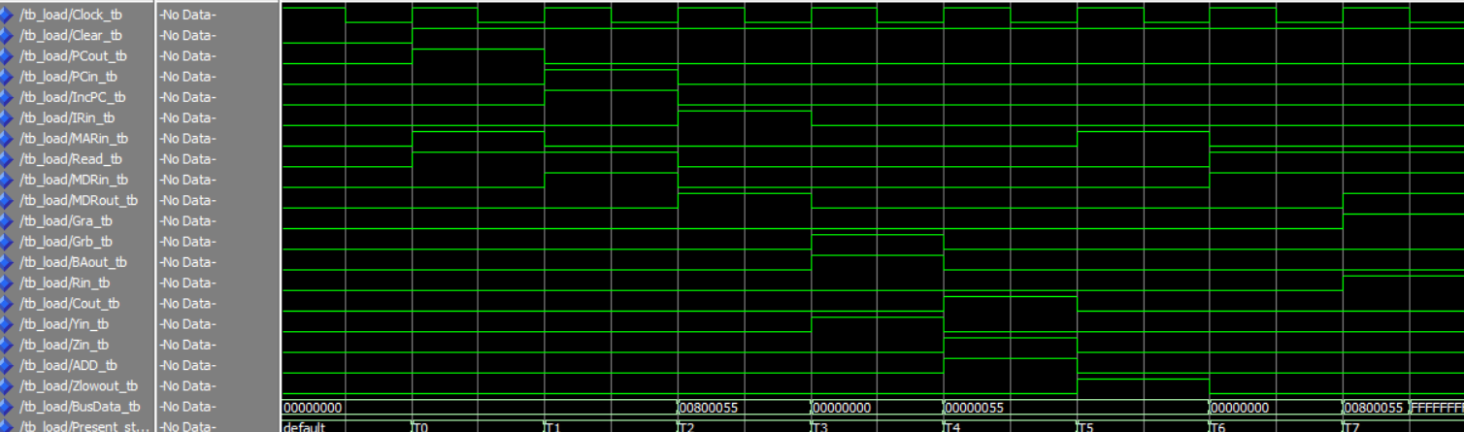

## Load R0, $35(R1)

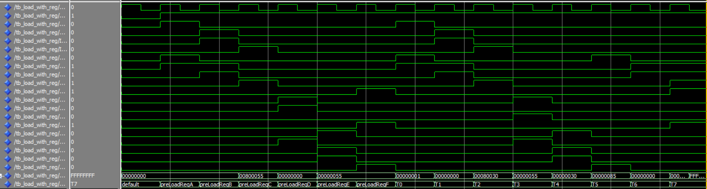

## Loadi R1, $55

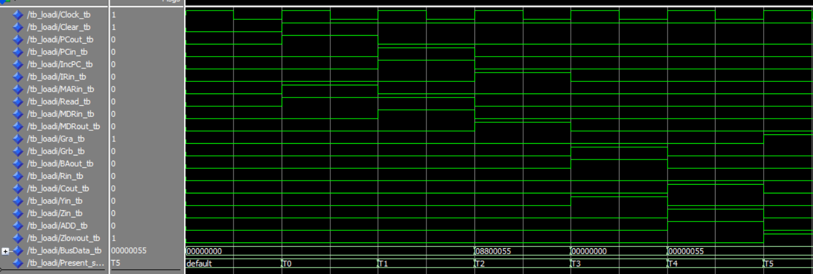

## Loadi R0, $35(R1)

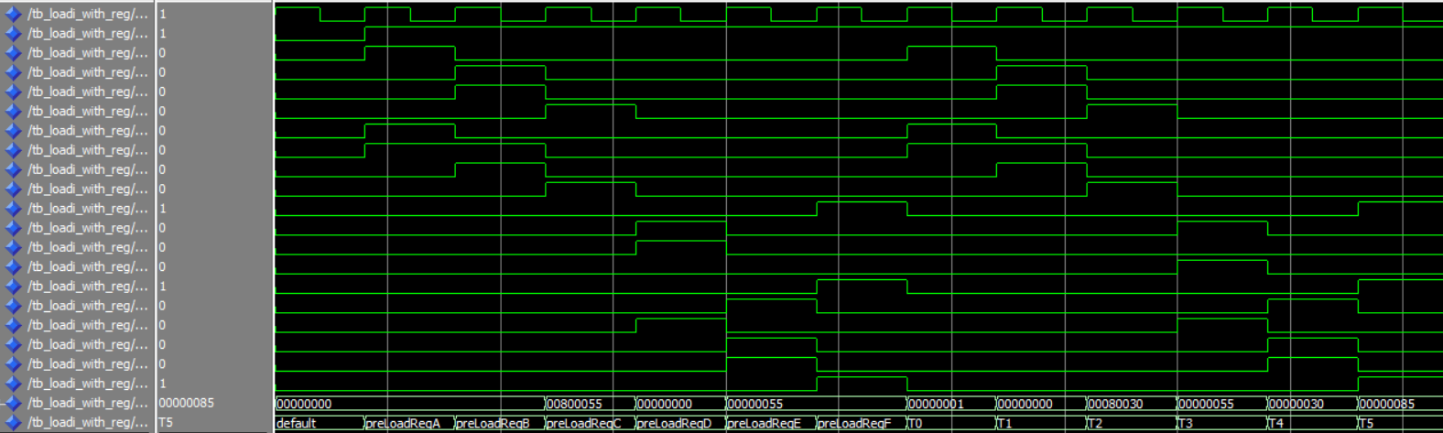

## Store $90, R1

**RAM Initializations**

ram(0) <= x"00800090"; -- Load first instruction at address 0 of ram

ram(1) <= x"00800090"; -- Load next instructions at the next ram address the next ram address

ram(144) <= x"FFFFFFFF"; -- This should be overwritten to 0x00000000 if store works correctly

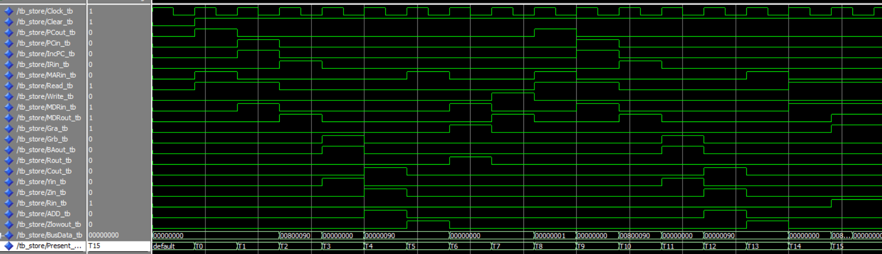

## Store $8F, R1

I’m showing this waveform to prove that the store instruction does work

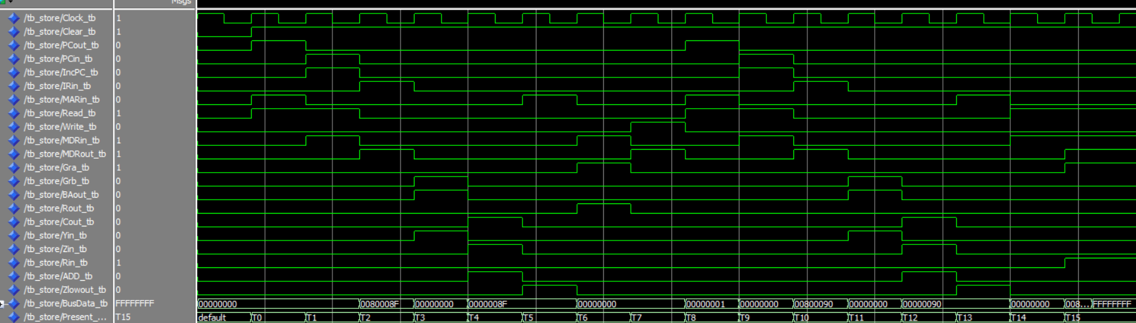

## Store $90, (R1)R1

**RAM Initialization**

ram(0) <= x"00800035"; -- Load first instruction at address 0 of ram

ram(1) <= x"00800090"; -- Load next instructions at the next ram address the next ram address

ram(2) <= x"00800090";

ram(53) <= x"00000001";

ram(145) <= x"FFFFFFFF"; -- This should be overwritten to 0x00000000 if store works correctly

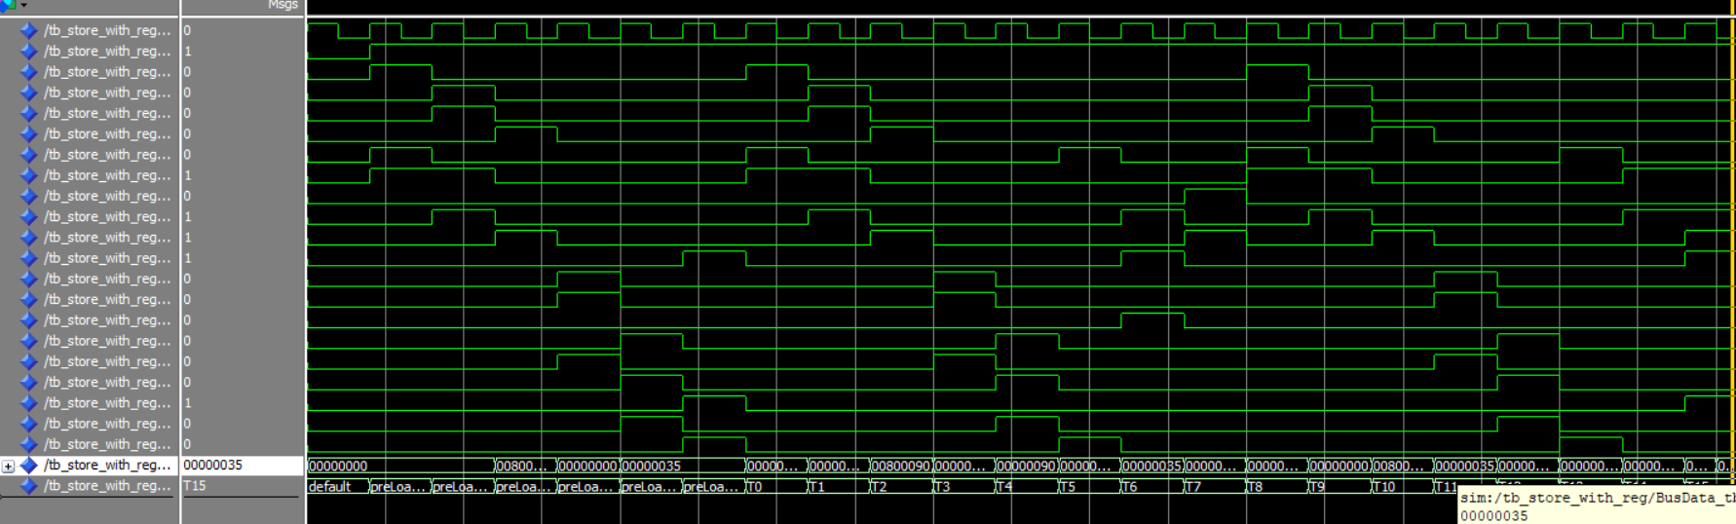

## Addi R2, R1, -5

**RAM Initialization**

ram(0) <= x"00800006"; -- Load first instruction at address 0 of ram

ram(1) <= x"010FFFFB"; -- Load next instructions at the next ram address the next ram address

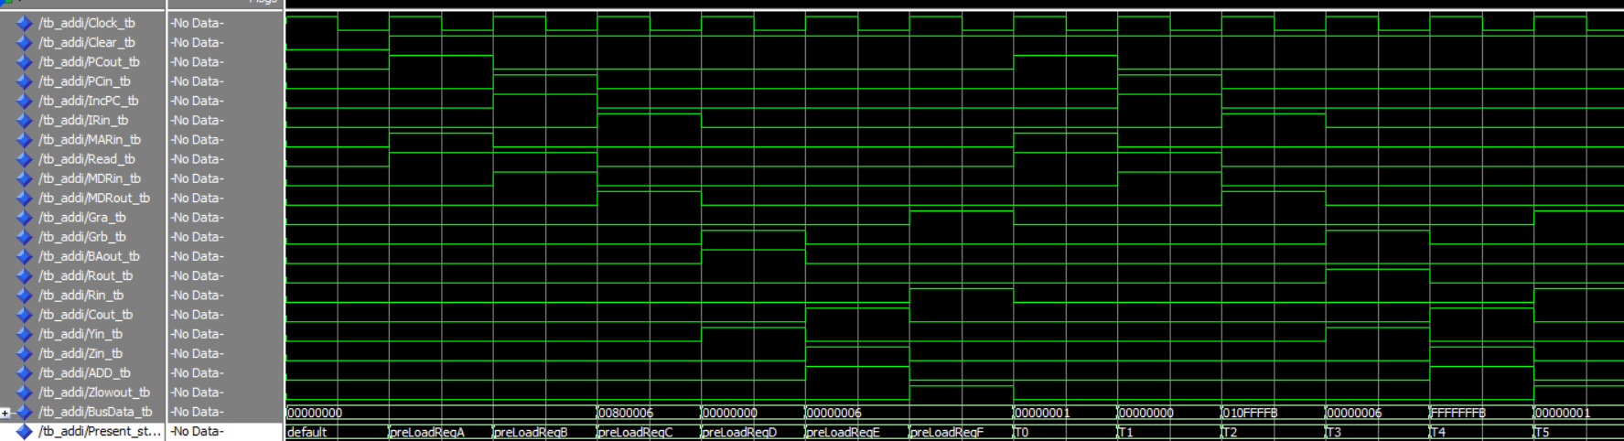

## Andi R2, R1, $26

**RAM Initialization (this is the same for ANDi and ORi)**

ram(0) <= x"00800022"; -- Load first instruction at address 0 of ram

ram(1) <= x"01080026"; -- Load next instructions at the next ram address the next ram address

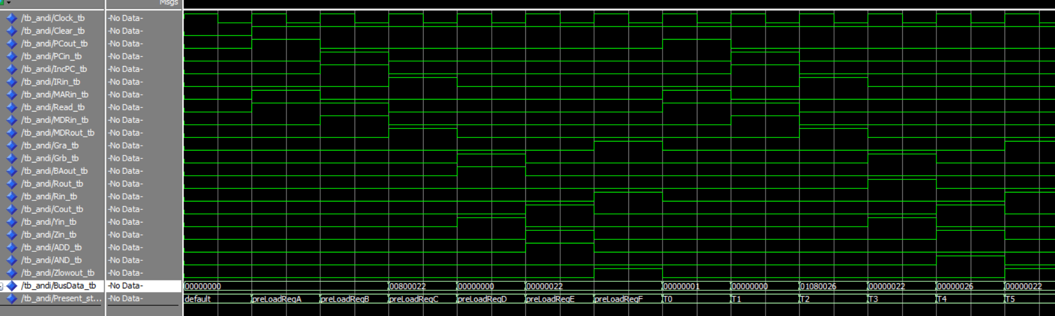

## Ori R2, R1, $26

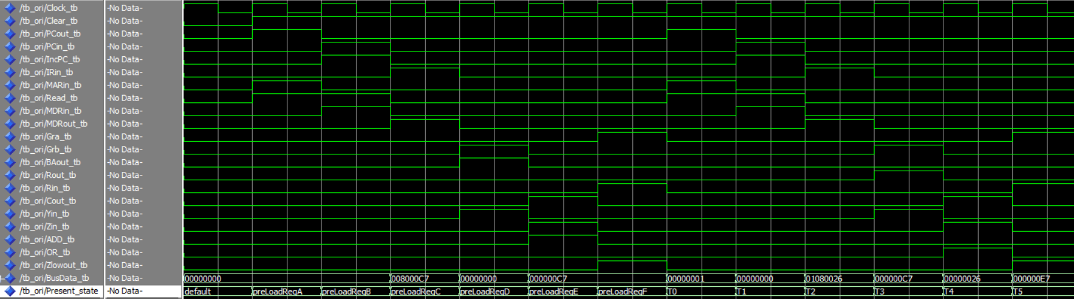

## Brzr R2, 35 (branch correctly taken)

**RAM Initialization**

ram(0) <= x"01000000"; -- Load first instruction at address 0 of ram

ram(1) <= x"0000000A"; -- Load next instructions at the next ram address the next ram address

ram(10) <= x"01000023";

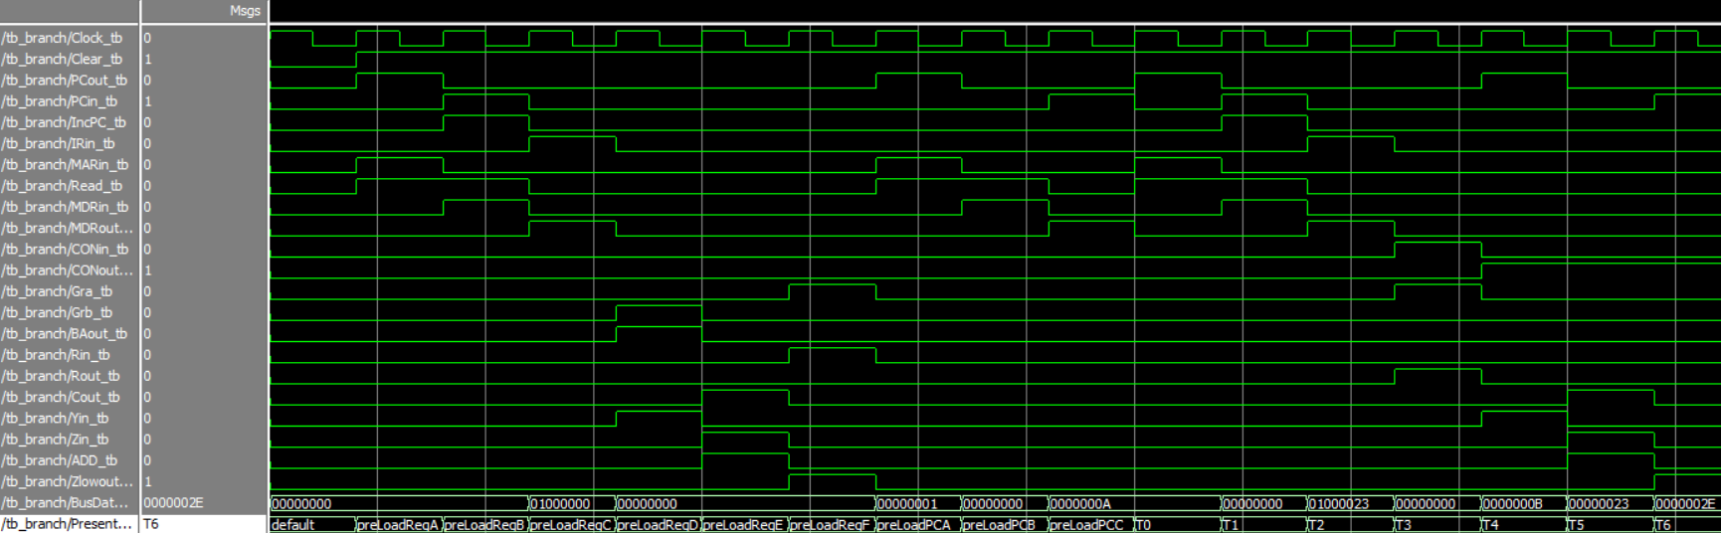

## Brzr R2, 35 (branch not taken)

**RAM Initialization**

ram(0) <= x"01000001"; -- Load first instruction at address 0 of ram

ram(1) <= x"0000000A"; -- Load next instructions at the next ram address the next ram address

ram(10) <= x"01000023";

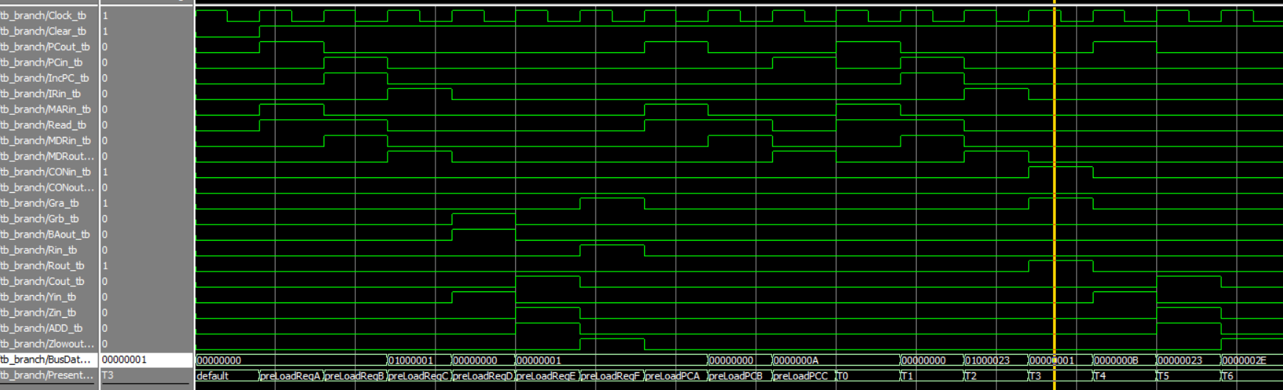

## Brnz R2, 35 (branch correctly taken)

**RAM Initialization**

ram(0) <= x"01000001"; -- Load first instruction at address 0 of ram

ram(1) <= x"0000000A"; -- Load next instructions at the next ram address the next ram address

ram(10) <= x"01080023";

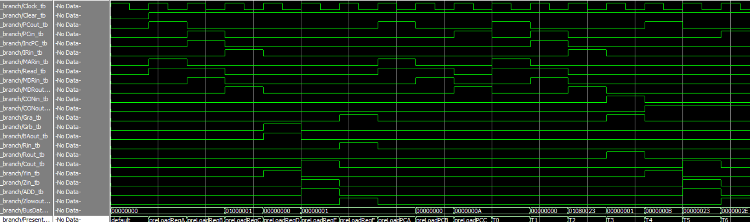

## Brnz R2, 35 (branch not taken)

**RAM Initialization**

ram(0) <= x"01000000"; -- Load first instruction at address 0 of ram

ram(1) <= x"0000000A"; -- Load next instructions at the next ram address the next ram address

ram(10) <= x"01080023";

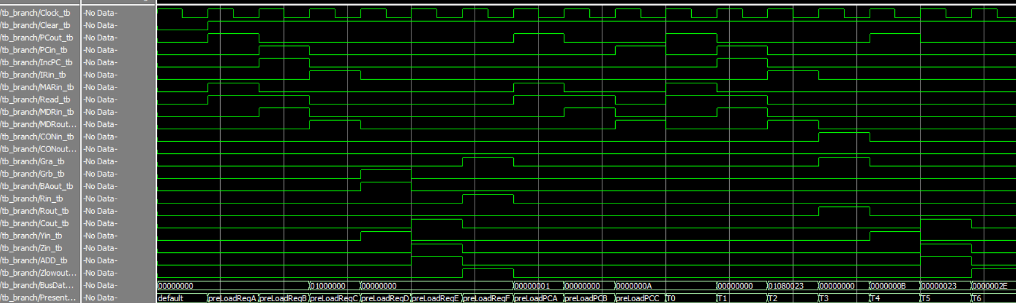

## Brpl R2, 35 (branch correctly taken)

**RAM Initialization**

ram(0) <= x"01000001"; -- Load first instruction at address 0 of ram

ram(1) <= x"0000000A"; -- Load next instructions at the next ram address the next ram address

ram(10) <= x"01080023";

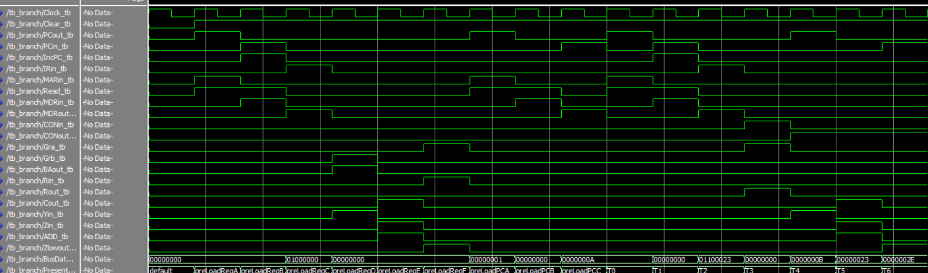

## Brpl R2, 35 (branch not taken)

**RAM Initialization**

ram(0) <= x"01040000"; -- Load first instruction at address 0 of ram

ram(1) <= x"0000000A"; -- Load next instructions at the next ram address the next ram address

ram(10) <= x"01100023";

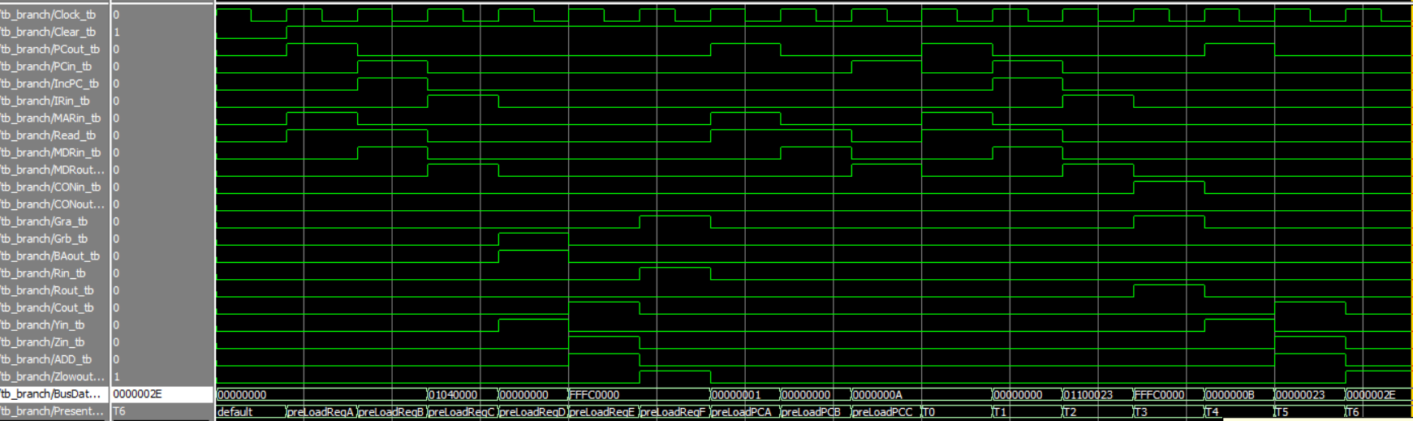

## Brmi R2, 35 (branch correctly taken)

**RAM Initialization**

ram(0) <= x"01040000"; -- Load first instruction at address 0 of ram

ram(1) <= x"0000000A"; -- Load next instructions at the next ram address the next ram address

ram(10) <= x"011C0023";

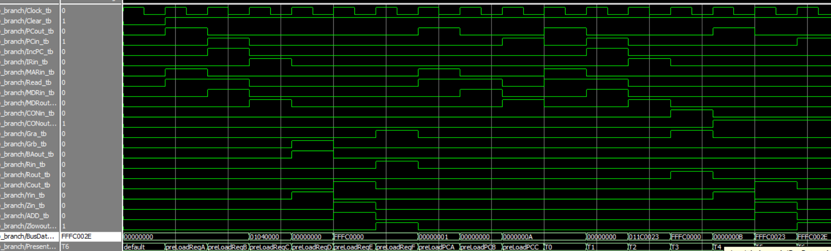

## Brmi R2, 35 (branch not taken)

**RAM Initialization**

ram(0) <= x"01000000"; -- Load first instruction at address 0 of ram

ram(1) <= x"0000000A"; -- Load next instructions at the next ram address the next ram address

ram(10) <= x"011C0023";

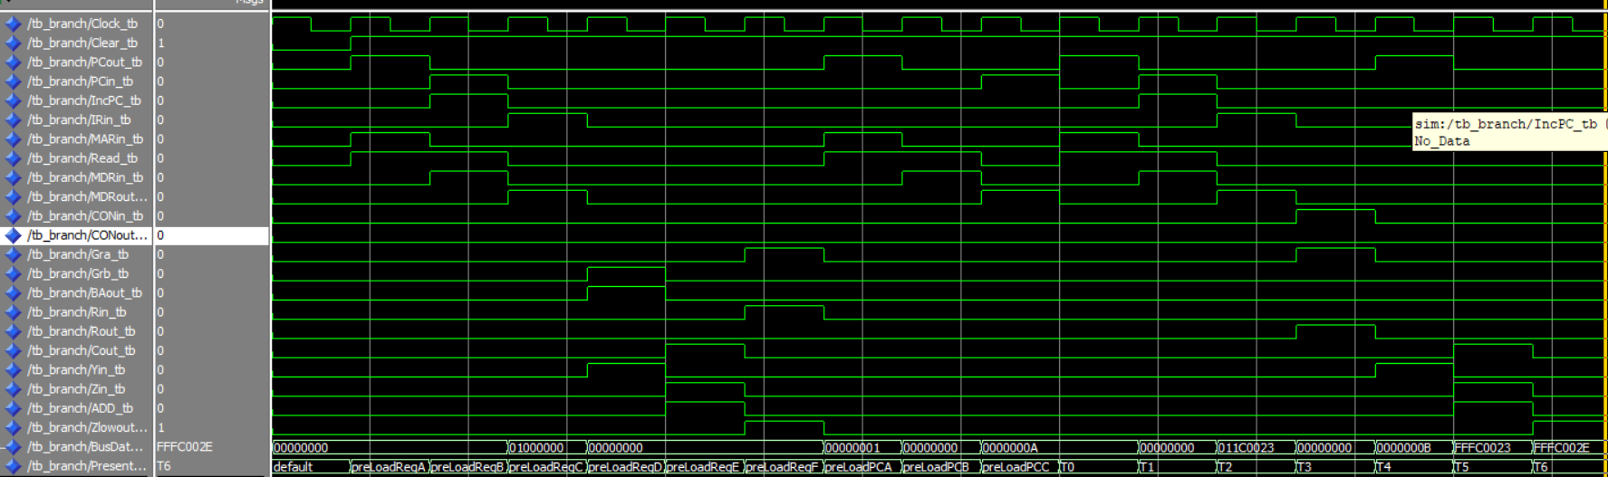

## Jr R1

**RAM Initialization**

ram(0) <= x"0080000B"; -- Load first instruction at address 0 of ram

ram(1) <= x"0080000A"; -- Load next instructions at the next ram address the next ram address

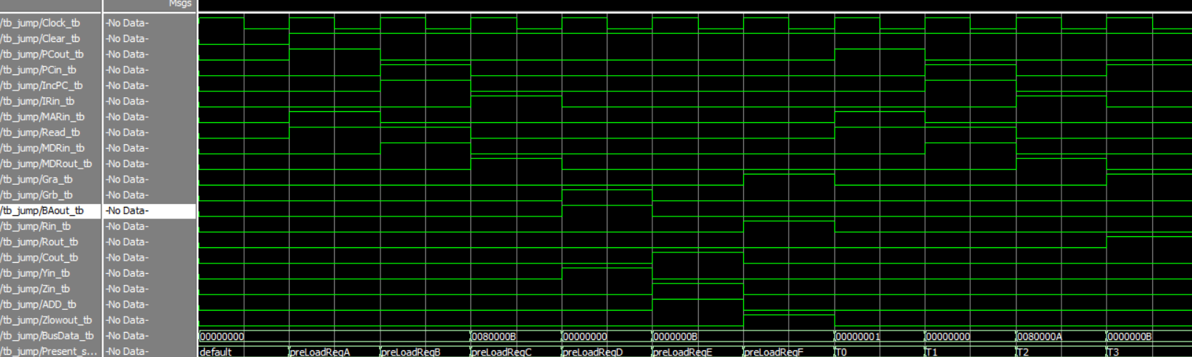

## Jal R1

**RAM Initialization**

ram(0) <= x"0F000000"; -- Load first instruction at address 0 of ram

ram(1) <= x"0080000A"; -- Load next instructions at the next ram address the next ram address

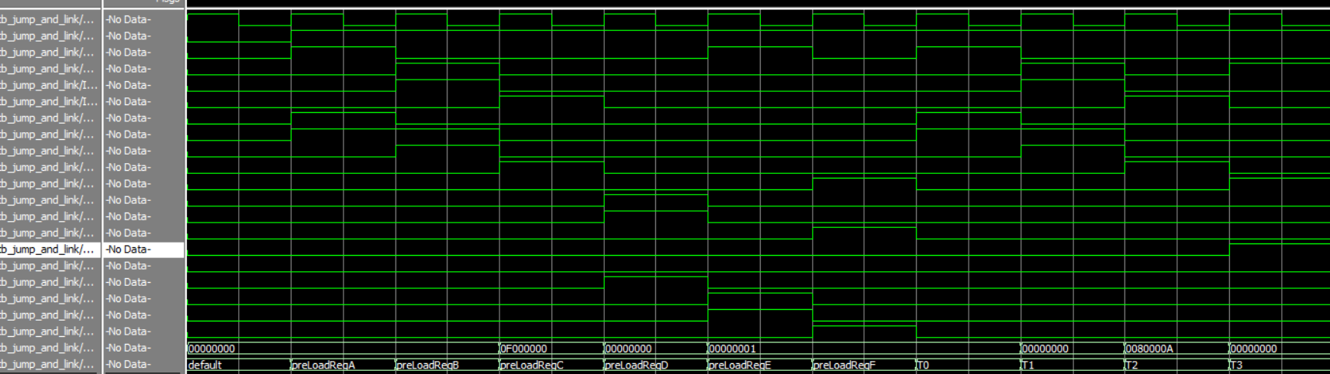

## Mfhi R2

**RAM Initialization (same for Mflo)**

ram(0) <= x"0F0F0F0F"; -- Load first instruction at address 0 of ram

ram(1) <= x"00100000"; -- Load next instructions at the next ram address the next ram address

## Mflo R2

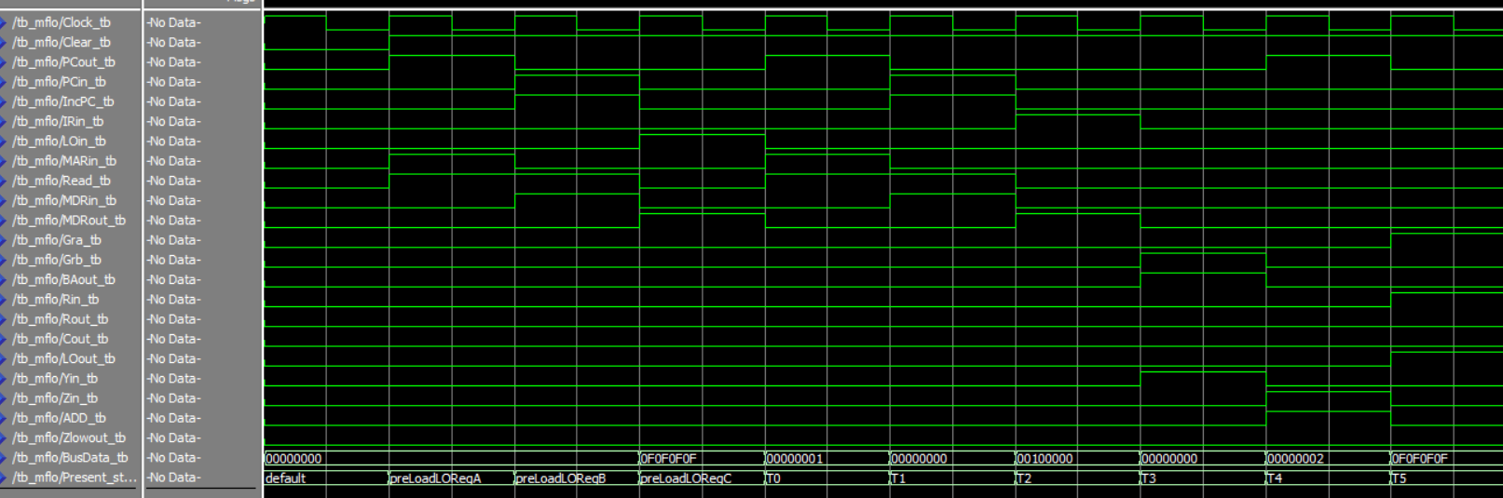

## Out R2

**RAM Initialization**

ram(0) <= x"01000FFF"; -- Load first instruction at address 0 of ram

ram(1) <= x"01000000"; -- Load next instructions at the next ram address the next ram address

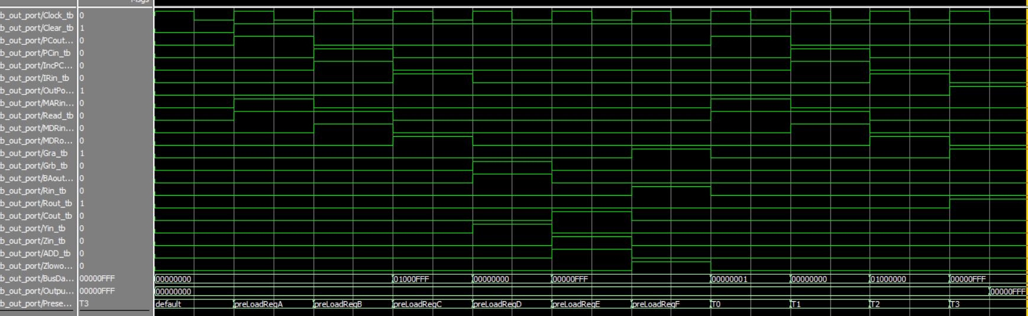

## In R1

**RAM Initialization**

ram(0) <= x"01000000"; -- Load first instruction at address 0 of ram

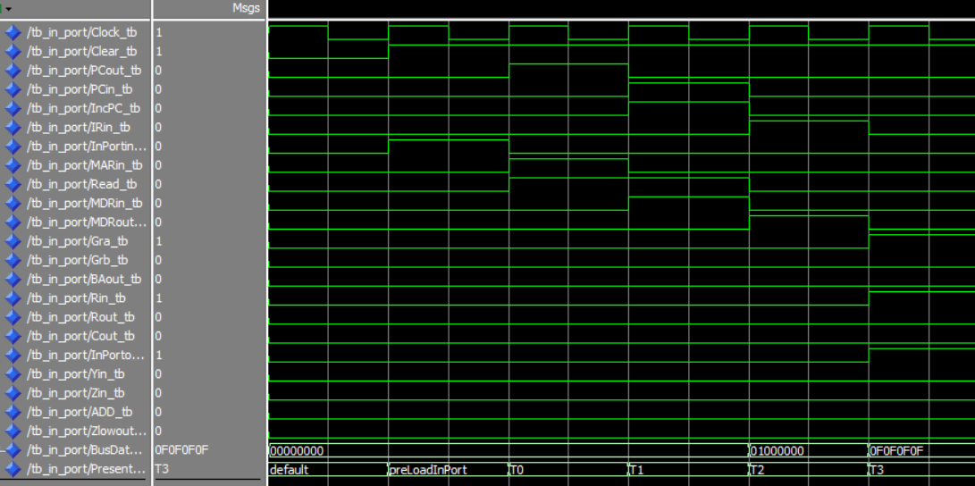

# Memory Contents

The following waveforms display the contents of RAM after a simulated store and load instruction have taken place (I have already proved in the sections above that these operations work), Note that it takes 2 clock cycles for the RAM to be written to/read from

